Project sponsor: NAU

Instructor: DR. David Traves

**Ali Almari Abdullah Alsayeh Mohammed Alanaqi Ali Alrashidi Omar Aldhafeeri Jassem Alhaddad**

**2019-2020**

**Department of Mechanical Engineering**

**North Arizona University**



# 

# DISCLAIMER

This report was prepared to fulfill course requirement. However, it is not the work of licensed engineers and has not been subjected to any form of detailed verification in engineering. The information and content of this report is not reliable but only after thorough testing and verification. University members who have assisted in this project are advisors, course instructors, and sponsors and are not responsible for the results.

# EXECUTIVE SUMMARY

Rube Goldberg Machines (RGM) are intentionally over designed, over engineered, complicated and entertaining solutions to perform a simple task. RGM consists of multiple steps arranged in sequence to complete the assigned task. At the start of the project, the team comprising of six students was given a task to design the steps of RGM that are entertaining, self-resettable, reliable, durable, easy to assemble and requiring minimal human interaction.

For designing the steps of RGM, team members interacted with all the stakeholders to find the customer requirement that needs to be fulfilled. The team derived the engineering requirement from the various requirements posed by all the stakeholders.

The team did a lot of research on the RGMs that are available in the internet to get the better understanding of the It. The team focused on the each and every steps of the RGM and discussed among us. Each team member was given the task to design the 2 individual steps of the RGM which were further discussed among the team members to evaluate each individual step based on the customer requirements. The tool used for evaluation of the individual steps is Pugh Chart and decision matrix. The steps those performs well in the evaluation were chosen for developing the prototype.

The design which turn out to be the best is “Pascal Law”. In this step, there is small weight on the small side and a larger weight on the larger side that are attached to each plunger. An actuator will be mounted parallel to the small side pipe. It will have a string or rope attached that will go through two pulleys that will connect it to the small side’s plunger. When the actuator goes up the weighted plunger on the small side goes down when the actuator goes down the plunger goes up. The device will function with the press of a button and automatically reset itself. When the button is pushed it will send a signal or trigger to two separate relays. They will be programmable relays.

The team has also researched on the wide range of material used for fabrication of the steps to make the step more and more entertaining.

The team is currently developing the prototype which will be arranged sequentially to perform the assigned task. The team may also modify the steps of RGM if the need arises during the development phase and testing procedures to increase its reliability and durability.

# ACKNOWLEDGEMENTS

Working on the Rube Goldberg Machine project was a source of immense knowledge to the rube Goldberg team. The team would like to express their gratitude to the project instructor Dr. Travis Head for their continual support and motivation throughout the project. The team is also helpful to all those are directly or indirectly associated themselves to the project for its success.

Rube Goldberg Team

# TABLE OF CONTENTS

DISCLAIMER 2

EXECUTIVE SUMMARY 3

ACKNOWLEDGEMENTS 4

TABLE OF CONTENTS 5

1 BACKGROUND 7

1.1 Introduction 7

1.2 Project Description 7

1.3 Original System 7

2 REQUIREMENTS 8

2.1 Customer Requirements (CRs) 8

2.2 Engineering Requirements (ERs) 8

2.3 Testing Procedures (TPs) 9

2.4 House of Quality (HoQ) 9

3 EXISTING DESIGNS 10

3.1 Design Research 10

3.2 System Level 10

3.2.1 Existing Design #1: Northern Arizona University 2018: Pouring a bowl of cereal 10

3.2.2 Existing Design #2: Purdue 2018: Apply a Band aid 11

3.2.3 Existing Design #3: Purdue 2018: Pouring a bowl of cereal 12

3.3 Functional Decomposition 12

3.3.1 Black Box Model 13

3.3.2 Functional Model/Work-Process Diagram/Hierarchical Task Analysis 13

3.4 Subsystem Level 14

3.4.1 Subsystem #1: Chain and Sprocket 14

3.4.2 Subsystem #2: Belt and Pulley 15

3.4.3 Subsystem #3: Springs 15

3.4.3.1. Existing Design #1: Compression Springs 15

3.4.3.2. Existing Design #2: Torsional Spring 15

3.4.3.3. Existing Design #3: Tension/Extension Springs 16

3.4.4 Subsystem #4: Lever Mechanism 16

3.4.5 Subsystem #5: Gears 17

3.4.5.1 Existing Design #1: Spur Gears 17

3.4.5.2 Existing Design #2: Helical Gears 18

3.4.5.3 Existing Design #3: Bevel Gear 18

4 DESIGNS CONSIDERED 19

4.1 Design #1: Conveyer Belt 19

4.2 Design #2 Hair Dryer 19

4.3 Design #3 Floating Mechanism 20

4.4 Design #4 Thrust Pad 20

4.5 Design #5 Hanging Ball 21

4.6 Design #6 Dominos 21

4.7 Design#7 Pascal Law 22

4.8 Design #8 Pulley and Link Mechanism 23

4.9 Design #9 Gate Link Mechanism 23

4.10 Design #10 Lever Mechanism 24

4.11 Design #11 Lifting Mechanism 24

4.12 Design #12 Chain and Sprocket Mechanism 25

5 DESIGN SELECTED – First Semester 26

5.1 Rationale for Design Selection 26

5.2 Design Description 27

5.2.1 Theoretical Analysis 29

5.2.1.1 Pascal Law (Ali Almari) 29

5.2.1.2 Conveyer Belt (Omer Aldhafeeri) 31

5.2.1.3 Hair Dryer (Jassem Alhaddad) 33

5.2.1.4 Lever Mechanism (Mohammed Abanaqi) 34

5.2.1.5 Sliding Door/RGM (Abdullah Alsayeh) 35

5.2.1.6 Cam and Dominos Device (Ali Alrashidi) 37

6 PROPOSED DESIGN – First Semester 40

6.1 Resource Utilized 40

6.2 Bill of Material and Budget Cost 41

7 CONCLUSION 42

7.1 Design Changes 42

7.2 Project Outcomes 42

REFERENCES 43

7 APPENDICES 45

7.2 Appendix A: House of Quality 45

7.3 Appendix C: Bill of material 47

# BACKGROUND

## Introduction

Rube Goldberg machine is a complicated machine which is designed using the simple steps of basic engineering to accomplish a given task in a most innovative and funny manner. The machine consists of several steps where each steps is triggered by the previous steps. In this design, the major focus will be on applying the theoretical lessons learned in various engineering courses into reality. The project will be of great significance to the sponsor and other stakeholders (fellow students) since it will be used to teach future students various engineering aspects and be used as a form of brainstorming and leisure project.

The major aim of this project is to create a cost effective, reliable, durable and unique Rube Goldberg machine that will be used to accomplish a given task. Since Rube Goldberg machine consists of many steps, it will help in better understanding of the physics basics and the student will be able to analyses the usefulness and importance of many machines which they come across in day today life. The team will conduct a lot of research and exchange ideas amongst themselves to make sure that the design will satisfy the customer need. The customer needs are the major points which must be considered to ensure success.

## Project Description

According to Wonder polis, a Rube Goldberg Machine is a device or apparatus that makes use of a chain of reactions to accomplish a very simple task in a manner which is indirect and complicated [1]. The team is required to create various steps of a Rube Goldberg machine such that in the end, it will accomplish the assigned task. In order to accomplish the goal, the steps involved should be complicated and must be presented in the professional manner. So, to induce the gears, sensors, springs, fluid, aerodynamics, and magnets must be used. Specifically, ten steps will be involved in this case and four minutes as maximum run time. The RGM is required to occupy an area of 10 feet by 10 feet and a volume of no more than 400 feet cubed. However, the steps that are involved in the chain reaction of the RGM should be reliable, resettable, efficient, and must have human integration in a step. In general, the whole set up should be entertaining to the audience.

## Original System

Our Rube Gold Berg machine started from the scratch with stand-alone ideas with no original system. In this regard, the team will embark on building an original device which has never been built before.

# REQUIREMENTS

The team’s goal is to create efficient, reliable, and resettable rebuild berg steps. The team is required to liaise with the client so that they can know the actual requirements that will be incorporated. First, there are customer requirements, and this will be obtained directly from the clients since they are the ones who are going to interact with the device for a long period of time. Customer requirements will be helpful in figuring out the Engineering requirements. Since the engineering requirements are specific and measurable, the future analysis of the various designs will be made easy. House of quality (HOQ) is a diagram and is a part of Quality Function Deployment (QFD) which relates the customer needs to how the team is going to achieve those by prioritizing the needs. All the requirements and HoQ are listed and explained in the following subsections.

## Customer Requirements (CRs)

Customer requirements are the various kind of requests which are given by the clients and the users. The major requirements are as follows:

* + 1. The steps should be efficient, reliable and durable so that it will not fail during demonstration.
    2. The steps used should be resettable.
    3. The setting time should not be very high.
    4. The steps involved needs to be complex, unexpected and entertaining to the audience.
    5. The speed of the steps should be normal such that the human eyes are able to capture every action.

All the steps should be safe so that it will not harm the audience as well as the audience. After liaising with the client, the team got the actual requirements that should be incorporated in the final design. The customer requirements were obtained directly from the clients because they are the ones who will interact with the device for long. The significance of each customer requirement is ranked on a scale from 1 to 5, where 5 represents the most significant whereas 1 represents least significant customer requirement. These customer requirements help in determining the specific and measurable quantities termed as engineering requirements.

## Engineering Requirements (ERs)

Engineering requirements are measurable quantity and derived based on the customer requirement. The engineering requirements makes work easier for future interpretation and analysis. The team derived the following ERs which are shown in Table 1 based on the CRs:

**Table 1: Engineering Requirements**

|  |  |
| --- | --- |
| **Engineering requirement** | **Target values** |
| Number of steps | 12 |
| Process duration | Less than 2 minutes |
| Size | 100ft2 |
| Speed | 10c/s |
| Sound | Minimum |
| Strength (psi) | 3000 |
| Reset period | 5 minutes |
| Precision (in) | 0.5 |
| Young Modulus | 100000 PSI |
| Aesthetically Pleasing (yes/no) | Yes |
| Accuracy (in) | 0.5 |
| Cost ($) | 1500 |

## Testing Procedures (TPs)

Testing procedures are the detailed laid down sequential activities which needs to be performed in order to test the prototypes for its effectiveness. These will help the team in evaluating the steps of the RGM based on the customer requirements. Testing procedures are relatively simple since the ERs which are derived from the CRs are measurable quantities. The dimensions can easily be measured with the scale. The time of the individual steps can be measured with the help of stopwatch. The machine can be checked for durability and reliability by running the machine multiple number of times. If machines respond similarly in all the runs that means machines is durable and reliable. By recording the audience response during its showcase, it can be evaluated the machine is entertaining or not. Number of steps can also be counted.

## House of Quality (HoQ)

The house of quality is used to show the relationship between the engineering requirements and the customer needs [3]. The major values included in this case are: the customer requirements, engineering requirements, weights, and target values. The engineering requirements were rated against the customer requirements and assigned a value of 0, 1, 3, or 9 depending on the relationship. A variety of values were applied with 0 representing no correlation, 1 representing a small correlation, 3 moderate correlation, and 9 representing a high correlation. Absolute technical importance was determined by multiplying the engineering requirement score by the relative weights of the customer requirements and finding the sum. Relative weighting was calculated by dividing the score of absolute technical importance by the highest points. A summary of the House of Quality is presented in **Table A.1** at **Appendix A**.

# EXISTING DESIGNS

A variety of competitions have been carried out regarding the Rube Goldberg Machine and as a result, the team conducted a research on them. It was no doubt that the team was supposed to conduct thorough research from a variety of sources such as the internet and interviewing users. The major emphasis was on designs which met the proposed customer requirements. In addition, the focus was on designs that had components which could be incorporated into the design at hand to satisfy the user’s needs. The existing designs are as follows:

## Design Research

Several designs were researched during the initial stages of the design process. The team started their search by looking for RGMs which are nearly similar to the one they are designing and at the same time an efficient one. In order to accomplish their search, the team used the internet whereby they incorporated search engines such as Google and video sites such as YouTube. In order to be precise, the major focus was on previous winners and where available we checked in their website to read about their machine in detail so that we could get a glimpse of how the RGM is supposed to operate in an effective manner. In addition, the team also wanted to create a machine that is unique from the already existing designs. The team also conducted oral interviews to the client and various stakeholders to determine the most appropriate needs that needed to be incorporated in the RGM design. In addition, the team conducted benchmarking using the already existing designs so that they can get ideas on how to design their RGM.

## System Level

With the years, several people have been working on the design of a Rube Goldberg machine bringing in new changes every time to improve on the machine’s performance and efficiency. The changes have been also attributed to by the new innovations on the technology and the changing customer requirements. For this reason, you will find that the design that was rated the most successive a few decades ago is now obsolete or of lower performance. In this project, our team conducted an online research and physical consultation of the professionals in the field to come up with the new technological advancements and developments in the market what should be incorporated in the Rube Goldberg project to improve on its appearance and operational effectiveness. In this section the major focus is on three system-level existing designs, described in sufficient manner to assess relevance and applicability in to this project.

### Existing Design #1: Northern Arizona University 2018: Pouring a bowl of cereal

This design was second in the 2018 USA competitions and it was comprised of 38 steps as follows. The gear mechanism, mouse trap, electrical circuit and DC motor is used to add the complexity. The best part of the machine is initiation with the alarm clock. The vibration energy is used to initiate the movement of the ball. To add the fun element the team has made use of the mouse trap, curtains and the shoe. The mechanism of machine has helped us in enhancing our ideas for making a unique and quality RGM. The machine is further discussed as:

The mechanism starts by turning on the alarm clock. The arm of the clock sends the ball down the track and tube. The ball turns to switch “off”. A metal ball is released from an electromagnet. The ball goes down the track, landing on a mouse trap. The mousetrap pulls the peg from under shoe. The shoe swings and kicks stopper. A fishing pole reels back. As the fishing pole reals back, a ball’s gate is pulled from its slot. The ball tumbles down spine track. It lands in a cup, pulling out the blockade. The soup can roll through cup tower, releasing weight. The weight pulls stopper from ball column. Balls release from the column, dropping into a cup. The cup falls, pulling open curtains, and landing on a long lever. The long lever triggers driving gear. Driving gear turns pinion, in turn moving the rack to the right. The top piece of wind-up toy pulls up the bottom piece. The bottom- half of wind-up toy rotates lever clockwise. A lever rotates fishing pole counterclockwise. A “Gate” lifts, releasing the first golf ball down its track. The golf ball falls into a mini cereal box, tilting the top track clockwise. The second golf ball rolls down the track and tube. The golf ball knocks out the wheel’s peg. The wheel spins, dumping cereal into a dispenser as it does so, and ultimately pulls up on the box door’s latch. The collapsing door falls, releasing a ball inside. The ball rolls down the track, bounces out of the box, hits the target, and bounces back in. the whale teeters tips. Cadillac Ranch “dominoes” fall. A hinge/latch is released. Malt milkshake cup falls. A nail is pulled from spoon launcher. The spoon launches into a bowl.

As soon as the spoon falls on the bowl, it senses and send the signal to DC motor that is attached to the handle of the cereal dispenser. Cereal exits dispenser and slides down a chute. Once 30 grams of cereal reaches the bowl, the DC motor turns off, and the stepper motor and its attached arm spin 180 degrees. A peg under the milk lever is swiped away by the stepper motor arm, tipping lever. Finally, milk pours into the funnel, through tubes, and into the cereal bowl.

### Existing Design #2: Purdue 2018: Apply a Band aid

The machine is setup in 57 step with the task of applying a band aid. The team had the theme of a “Dinner Date Disaster”. The machine was based in a kitchen and many of the steps used objects like a frying pan, cheese slicer, wooden spoon, ketchup bottle, candle, microwave and a rolling pin. The best part of the design was taking advantage of the height (potential energy) with the help of the two walls. The major attraction of the design were the steps like falling of the painting from the wall, Use of the magnets. The idea of moving the steel ball with the help of magnet can be effectively modelled during the development of our unique design.

The machine starts when the user hits the frying pan that hits the flour box. The floor box closes the door of the microwave which hits the card board flame. As a result, white marble rolls down to trigger the mouse trap which releases the cheese slicer. When the weighted lever pulls up candle, the magnet on the bottom of the candle lets go of weighted magnet which triggers the mouse trap to release the kettle by the slipping action of the string. In other step the motion of the magnetic ball causes the motion of steel ball which hits the catch to open the lid of a pizza box. A wooden dowel is to the blender. One end of a string is connected to that wooden dowel while the other end is attached to a curtain. When the previous step triggers the blender to turn on, the string is wound up which results in opening the curtain. The idea of using the magnetic energy and the rotational energy to wind/ open something can be effectively incorporated in the team design. The task was to apply the band aid which is applied by laying over a rolling pin that rolls on the table top. The steps include knocking off the train stopper by the silver marble. Removing the stopper results in rolling down the train against the ramp, Train pulls spatula to push the corkscrew arm which turns spreader. The spreader pushes the rolling pin to apply the band – aid. This is the best example how the simple and smaller steps can be effectively used to complete the task.

### Existing Design #3: Purdue 2018: Pouring a bowl of cereal

This machine won the first place in the 2018 Rube Goldberg Machine Contest college division at Chicago’s Museum of Science and Industry. Design consists of 75 steps. The design focused on the one which pours a bowl of cereal and is comprised of three separate vignettes which were each rotated into view when the previous steps were complete. The best part of the machine is the use of wind mill and making it in the three separate vignettes since this adds the difficulty and error in movement of wheel and locking at the exact place may cause the fail in triggering the next step. The main attraction of the machine is the whirlpool sucking the ice cube, dropping the bowl and boxing gloves, card trick, door, and lifting the box containing cereals which can be incorporated in our machine after some improvement.

In the first vignette, a jug which is placed on a board triggered the operation of a blending machine which in turn triggered the plucking of wires of a guitar. Then the ball started rolling through a variety of steps which involved falling though hollows and being thrown to targets by use of springs and falls on the cup which releases Gane. The Gane pushes the ball to knockdown the knife. The knife releases the map and map throws a punch by releasing weight which in turn tips over the stool to escape through the door which triggered the broom to release the Bowl. In the second vignette, the fan rotates thus blowing the ball which flows through a variety of stages and at the same time dropping downwards. There are a variety of gears and hinges which facilitate opening and movement of some equipment. The ball eventually drops to a jar which turns and starts pouring water which in turn makes a turbine to rotate. In the third vignette, it is comprised the most innovative final step whereby a bowl of cereal was poured. In this case, there was a primitive hydraulic arm made of wood and syringes, which lifted and turned a Cheerios box for pouring the cereals.

After pouring the cereals, a pin attached to the cereal box hits the ring at the board which triggers the movement of the ball which results in the rotation of the wheel to get the final vignette. After rotation a pin attached to the structure which holds a tube for pouring the milk is removed which triggers the pouring of milk to the funnel. Milk travels through the plastic tube poured into the bowl.

## Functional Decomposition

In this project, the major aim is to create a reliable and durable Rube Goldberg machine that will accomplish an assigned task. The functional decomposition of the team is to design a device that meets all the requirements given by the client. However, this section contains a black box model and functional model of the device, to be achieved in the project. When both models are analyzed and utilized, there is the identification of the focus of the device for further emphasis in the design process.

### Black Box Model

In the black box model, the major focus is on the various mechanisms and operations of the device that eventually leads to the completion of task assigned. In order to represent all these processes, a box will be used as a simulation of the entire machine whereby inputs on the machine will be presented on one side whereas outputs are presented on the other side. In the black box model, the inputs which are being considered include the various forces which are incorporated for energy production, the types of materials and gadgets which have been used and the way they are linked to each other to ensure that there is a smooth flow of the entire process. However, it should be noted that there is a combination of mechanical and electronic elements which lead to the production of various forms of energy including mechanical and electrical energy. There is also the potential energy which is presented by the water which is stored ready for releasing or some other sort of material like the sand which is stored so that once it is released, it will trigger another action. For instance, at the start of the steps, there is the input of human energy whereby the ball must be set rolling by the hitting action. In other parts, the rotating gears and wheels lead to the production of kinetic energy which triggers some actions. For instance, the rotating wheel with a hook leads to knocking down of a bucket full of water. The magnet can also be used for removing the pin or movement of the metallic ball. However, the major form of outputs which are manifested in this design includes the production of a various form of sounds as result of rolling and dropping of the ball on various paths, lighting and the pouring to accomplish the goal of machine.

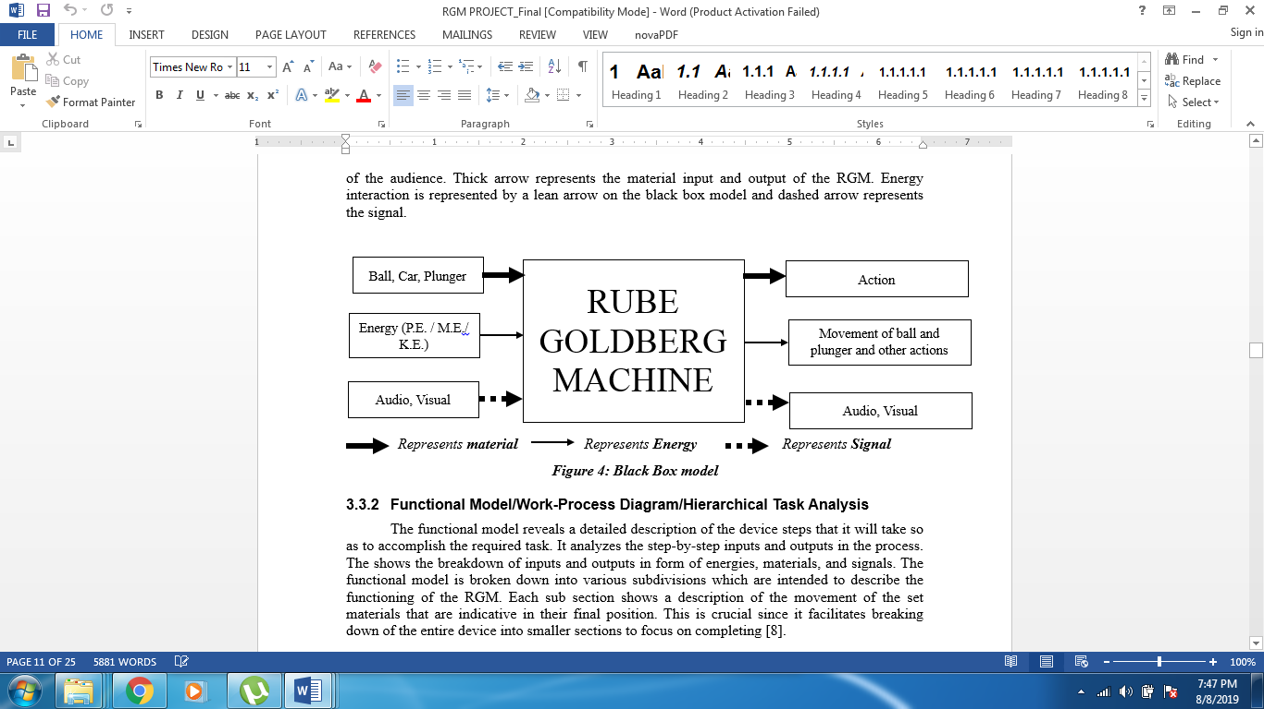

***Figure 1: Black Box model***

### Functional Model/Work-Process Diagram/Hierarchical Task Analysis

The functional model reveals a detailed description of the device steps that it will take so as to accomplish the required task. It analyzes the step-by-step inputs and outputs in the process. The shows the breakdown of inputs and outputs in form of energies, materials, and signals. The functional model is broken down into various subdivisions which are intended to describe the functioning of the RGM. The design has integrated various mechanisms to come up with an amazing and unique device that will effectively achieve the project objectives. Some of the main mechanisms in the process involve potential energy, potential energy, magnetic energy electrical energy, mechanical energy and human energy as well. Each sub section shows a description of the movement of the set materials that are indicative in their final position. This is crucial since it facilitates breaking down of the entire device into smaller sections to focus on completing [8].

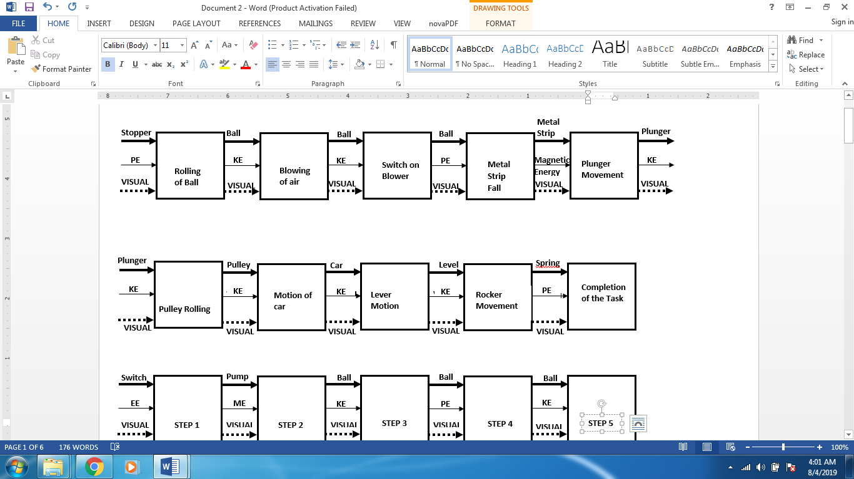

***Figure 2: Simple Functional Decomposition Model***

## Subsystem Level

In this section, the major focus is on three subsystem-level of the already existing designs. The idea is to assess the relevance and applicability to this project.

### Subsystem #1: Chain and Sprocket

A sprocket is a toothed wheel that fits onto a shaft. It is prevented from rotating on the shaft by a key that fits into keyways in the sprocket and shaft. While a chain is used to connect two sprockets. One sprocket is the driver sprocket. The other sprocket is the driven sprocket. Motion and force can be transmitted via the chain from one sprocket to another, therefore from one shaft to another. Chains that are used to transmit motion and force from one sprocket to another are called power transmission chains.

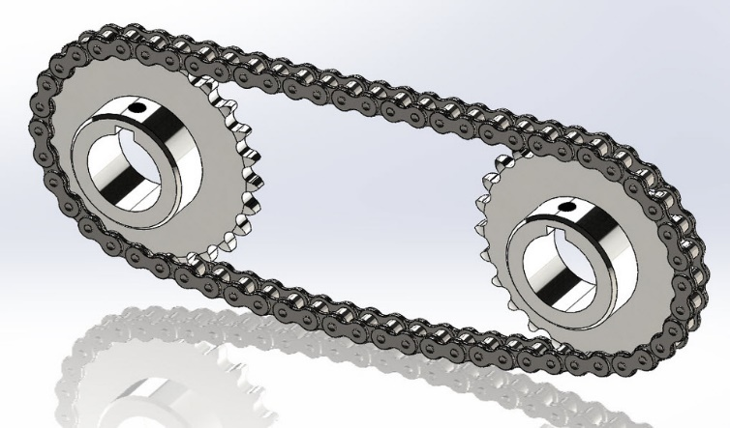

***Figure 3: Chain and Sprocket***

### Subsystem #2: Belt and Pulley

A drive of this type consists of an endless belt fitted tightly over two pulleys (driving and driven) transmitting motion from the driving to the receiving pulley by frictional resistance between belt and pulleys. The flexibility of the belt makes it possible to arrange the shafts of the driving and driven pulleys in any manner and to use as many pulleys as necessary.

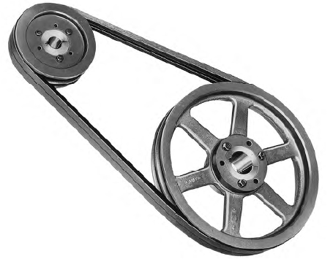

***Figure 4: Belt and Pulley***

#### Subsystem #3: Springs

Springs are very crucial in this project as they will be used to make launcher, pop things out from a box, or even make things turn in a circle direction.

##### Existing Design #1: Compression Springs

Compression springs are made from coils. It works by putting load on the spring and it will compress and store energy, and after that it will go back to its original place releasing the stored energy. Which can be used as a launcher.

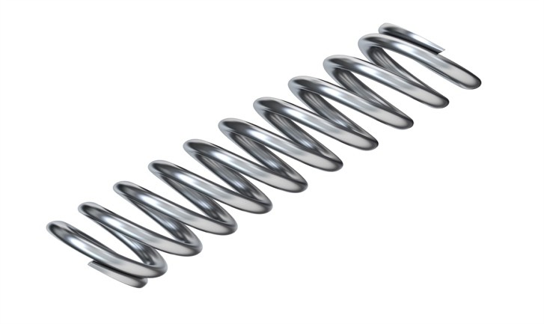

***Figure 5: Compression Spring***

##### Existing Design #2: Torsional Spring

The torsional spring does not compress or extend but instead it works by twisting it to store the potential energy. They follow Hooke’s law in an angular form. They can be seen in a lot of application examples like mouse trap or having a car move by itself.

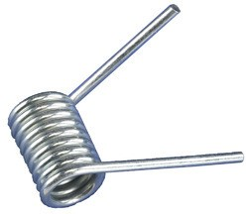

***Figure 6: Torsional Spring***

##### Existing Design #3: Tension/Extension Springs

This kind of spring works by extending the spring therefore it will have a lot of potential energy and by releasing the spring it will transform the potential energy into kinetic energy. Some of the application examples are building launchers, trampolines, and car manufacture.

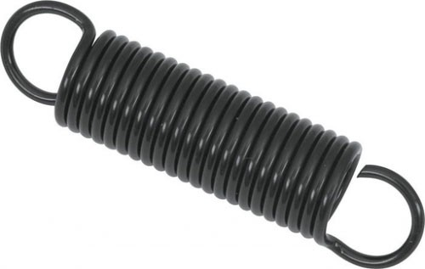

***Figure 7: Tension/Extension Spring***

#### Subsystem #4: Lever Mechanism

A lever is simply a plank or ridged beam that is free to rotate on a pivot. It is perfect for lifting or moving heavy things. It is a very useful simple machine, and you can find them everywhere. When you push down one end of a lever, you apply a force (input) to it. The lever pivots on the fulcrum and produces an output (lift a load) by exerting an output force on the load. A lever makes work easier by both increasing your input force and changing the direction of your input force.

There are three classes of lever based on the position of fulcrum, load and effort. In 1st class, the Fulcrum is between the Effort and the Load. The mechanical advantage is more if the Load is closer to the fulcrum. Examples of Class One Levers include seesaws, boat oars and crowbar.

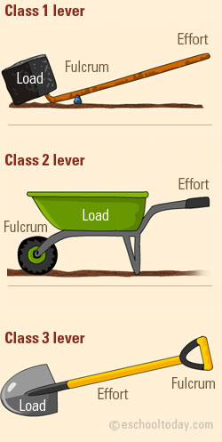

***Figure 8: 1st Class of Lever***

In 2nd class, the Load is between the Effort and the Fulcrum. The mechanical advantage is more if the load is closer to the fulcrum. Examples of Class Two Levers include wheelbarrows.



***Figure 9: 2nd Class of Lever***

In 3rd class, the Effort is between the Load and the Fulcrum. The mechanical advantage is more if the effort is closer to the load. An example of Class Three Lever is a garden shovel.



***Figure 10: 3rd Class of Lever***

#### Subsystem #5: Gears

Gears are used to transmit forces and rotations from the shaft which is driving to the one being driven. They are crucial in our project as they will help in efficient movement of some components.

##### Existing Design #1: Spur Gears

As seen from Figure 11, spur gears are cylindrical gears with a tooth line which is parallel and straight to the shaft. These gears are crucial in our project since they are able to achieve high accuracy with easy production processes. This will also help in maintain the angular speed by selecting the number of teeth in both the gears.

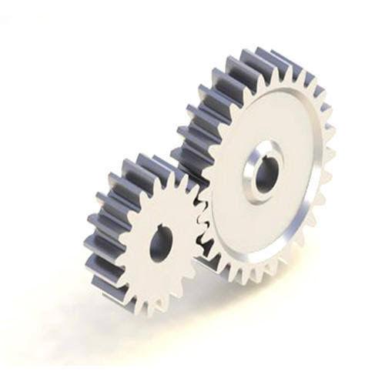

***Figure 11: Spur gears***

##### Existing Design #2: Helical Gears

The teeth in the helical gears are inclined with the shaft. These gears facilitate the gradual engagement and disengagement which will reduce the impact load coming onto the teeth of the gear. They are suitable in our project since they are able to transmit higher loads at high speed and with superior quietness. A diagram of helical gears is shown in Figure 12.

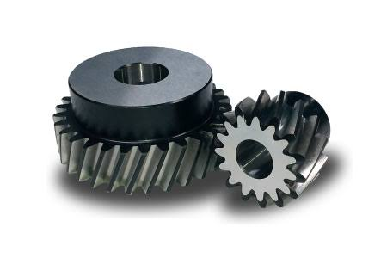

***Figure 12: Helical gears***

##### Existing Design #3: Bevel Gear

Bevel gears are [gears](https://en.wikipedia.org/wiki/Gears) where the axes of the two [shafts](https://en.wikipedia.org/wiki/Shaft_(mechanical_engineering)) intersect and the [tooth](https://en.wikipedia.org/wiki/Gear_tooth)-bearing faces of the gears themselves are conically shaped. Bevel gears are most often mounted on shafts that are 90 degrees apart but can be designed to work at other angles as well. An isometric view of bevel gear is presented in Figure 13.

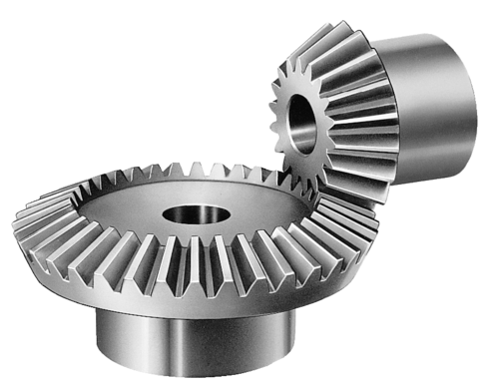

***Figure 13: Bevel Gear***

# DESIGNS CONSIDERED

This section entails descriptions of at least ten different designs. A comparison of various designs is explained in detail by considering the customer and engineering requirements. In addition, there is a clear indication of merits and demerits of each design considered. The individual steps are then combined in transitional steps to come up with a completely unique design that will effectively serve its purpose. The selection of the best design depends on a few factors. These factors may include; the materials used in the design. Different materials have different adaptations to temperature and load variation. The cost of production of the design was another important factor considered. Which is the most affordable and productive alternative to manufacture. Third on the list of the factors to consider is the need and demand of the design. How applicable is the design to the modern problems and what percent of the need will it satisfy. Lastly, we have the availability of materials. The selected design will be selected from what is readily available to design it. These steps are well explained in detail in the following subsections.

## Design #1: Conveyer Belt

In this step, of this Rube Goldberg Machine, there is human intervention whereby a human hand is used to put power switch on so as to start the belt of conveyer. As the belt moves, it moves the car along to the gate at the end. The car hits the switch, installed in gate, the motor installed in the gate of the ramp starts and move up the gate. The setup is presented in the Figure 14 below.

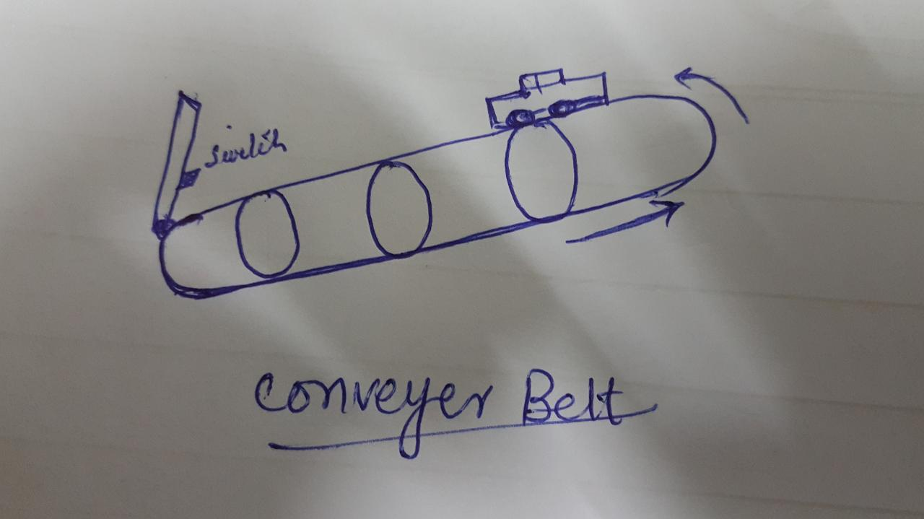

***Figure 14: Schematic diagram of Car on the Conveyer Belt***

## Design #2 Hair Dryer

The setup shown in Figure 15 explains the mechanism of the gate in front of the hair dryer at the start of ramp. The gate, as explained in previous section, will move up as the car hits the gate. The gate when reach the specific height, it will come automatically to its original position. As the gate lift up, Hair dryer will move through it for the next step. There is slope in the ramp through which the gravitational load will move along the ramp.

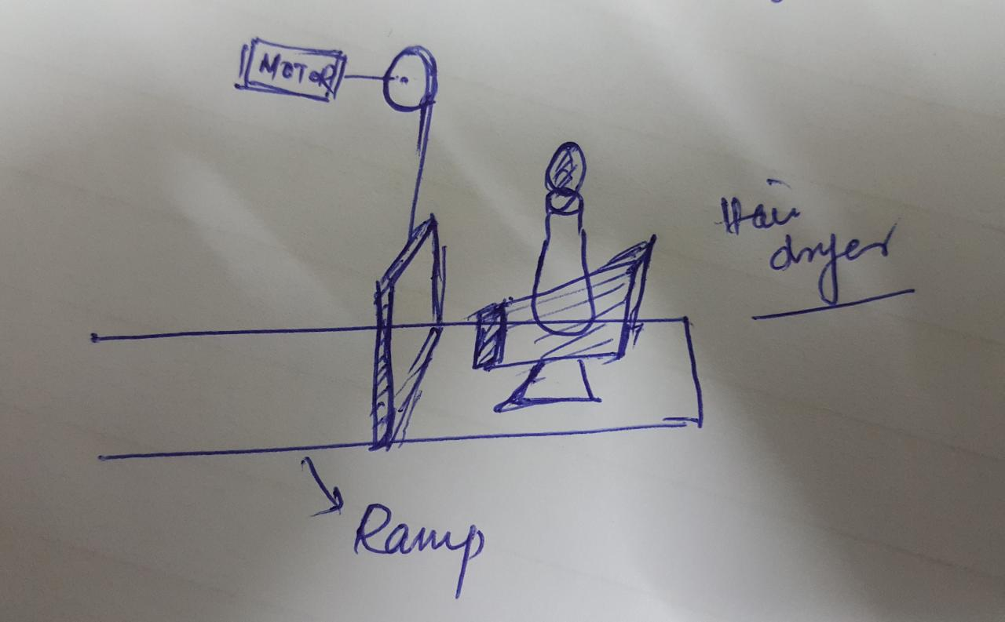

***Figure 15: Schematic diagram of Hair Dryer and Gate on Ramp***

## Design #3 Floating Mechanism

The step of RGM shown in Figure 16 possesses a Hair dryer from the previous step. The weight operated is switch installed in the ramp. As the cart of the hair dryer moves above the switch, it starts and float the ball along for the next path of the ramp. The hair dryer when passed through the switch, it turns off and moves forward to the chain and sprocket which will place the hair dryer to its original position and make the process resettable.

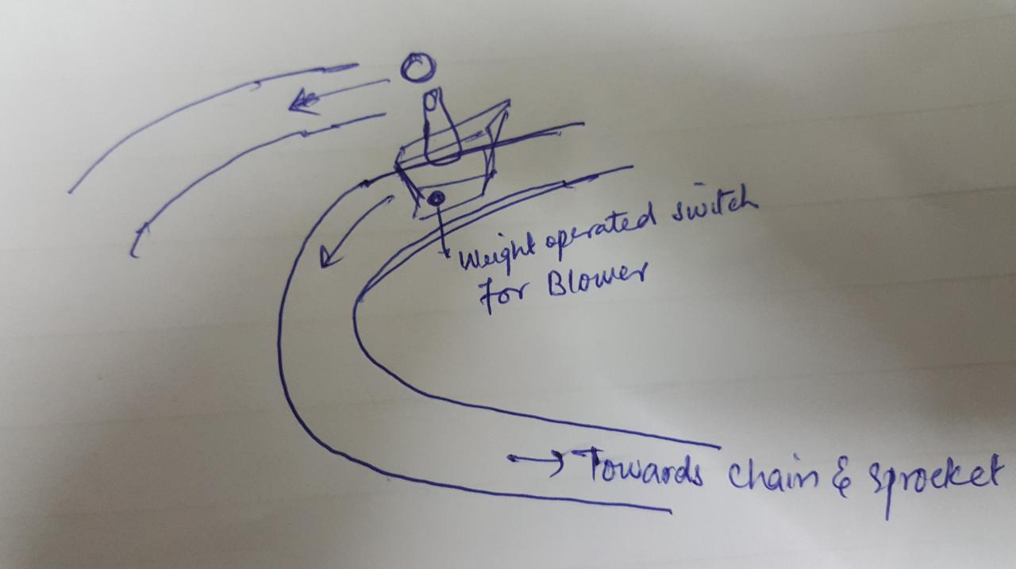

***Figure 16: Schematic Diagram of Blower along Ramp***

## Design #4 Thrust Pad

The step presented in Figure 17, is supposed to gain the momentum. When the ball hits the thrust pad, it will gain momentum which is needed for the next step. The ball after leaving the hair dryer through floating in the air, moves towards the thrust paid. The ball moves along the ramp with only gravity. In order to accelerate it, thrust pad is installed in the path of the ramp. The thrust is the spring system in which energy is stored in the elastic form. The thrust help in momentum gain which is needed to execute the next step. The ball velocity will increase, and it will rush along the ramp.

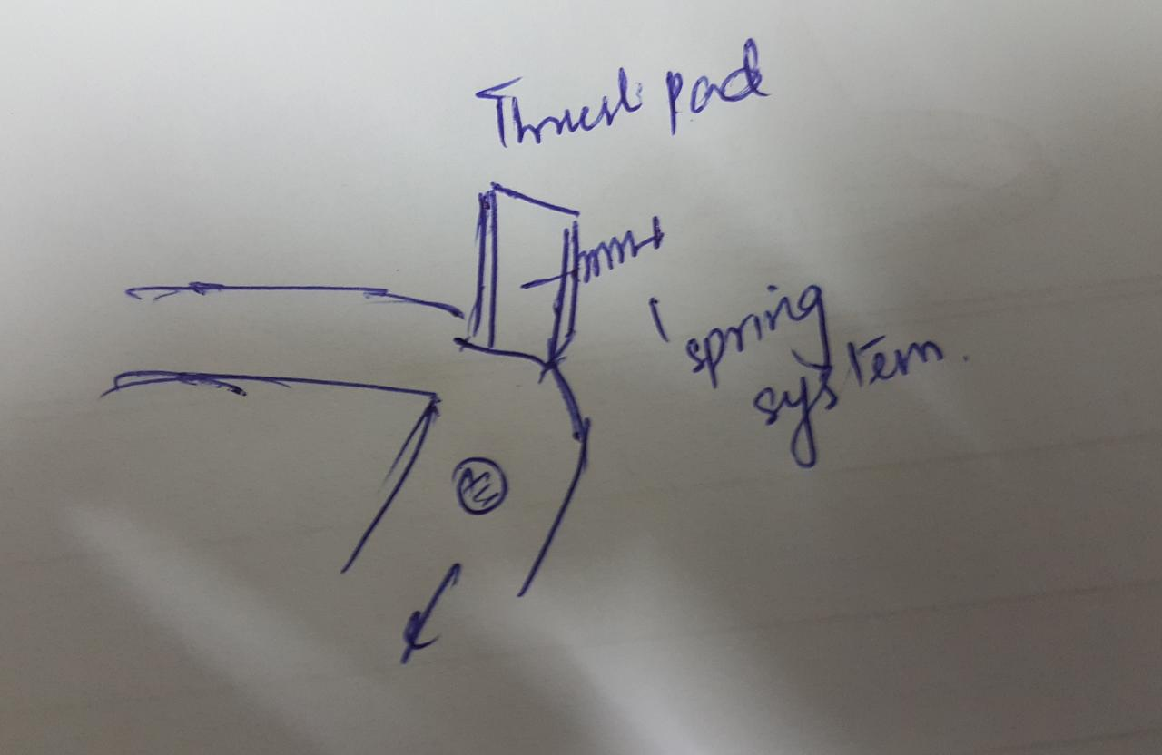

***Figure 17: Thrust Pad***

## Design #5 Hanging Ball

The ball which have high velocity and hence large momentum will hit the hanging ball in the path of the ball. The momentum will be transferred to the overhanging ball. There will 4 balls in overhanging system. The momentum will be shifted from one ball to another ball which will ultimately be utilized in the next step. This mechanism is shown in Figure 18. The ball on the ramp will continue its movement along the ramp to the end. The ball at the end of the ramp will be move up to its initial position using chain and sprocket mechanism.

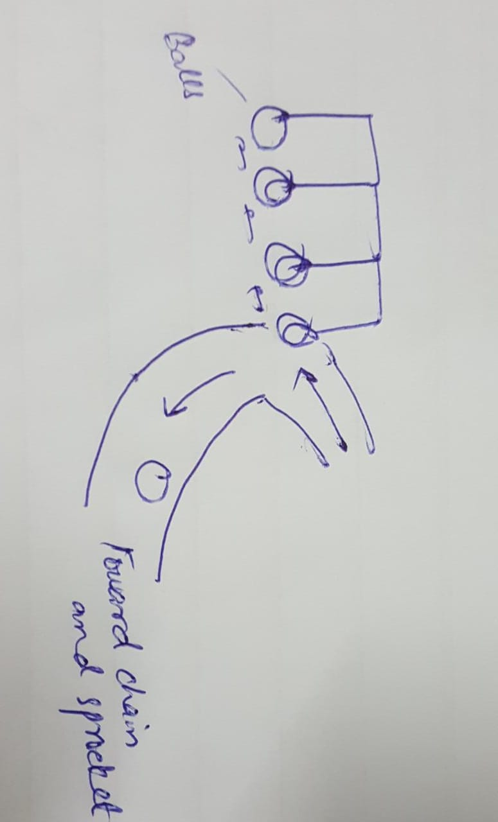

***Figure 18: Hanging Balls***

## Design #6 Dominos

The hanging ball after taking momentum from the ball on the ramp will ultimately transfer this momentum to the last hanging ball. The last hanging ball will hit the dominos which will fall by this impact. At the end of the plane on which dominos are placed, there is electromagnetism which hold the weight. When last dominos fall on that particular area, the electromagnetism is vanished resulting in falling of the weight. This weight will have impact which will be used in next step. The dominos have metal strip at their top and hinges at their bottom. There is electromagnet installed at their top, when it is in ON position, it will place the dominos back to their original position as they have metal strip at their top. Similarly, when the last dominos is raised from its fallen position, the electromagnetism will start again which will attract the weight and placed it on original position. These process is illustrated in Figure 19.

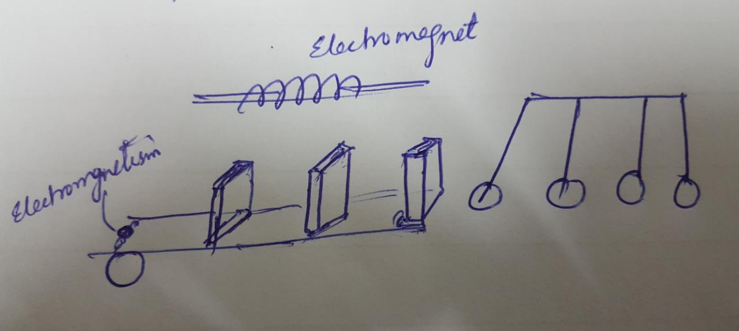

***Figure 19: Schematic diagram of Dominos***

## Design#7 Pascal Law

A schematic diagram of the plunger assembly is presented in Figure 20. In this step the weight from the previous step fall on the start button of the actuator for plunger assembly to push the plunger following the Pascal law. The Pascal Law which says that the pressure is equally distributed in the fluid which will result in increase of the force on the piston of lower area. The weight, placed on the plane in which dominos are placed, should be greater than the difference of two weights attached to the pulley. When the weight falls on the piston it will result in downward movement of plunger. As one of the plungers starts moving downwards, the plunger of the other side will start gaining height which can be used for triggering the next step.

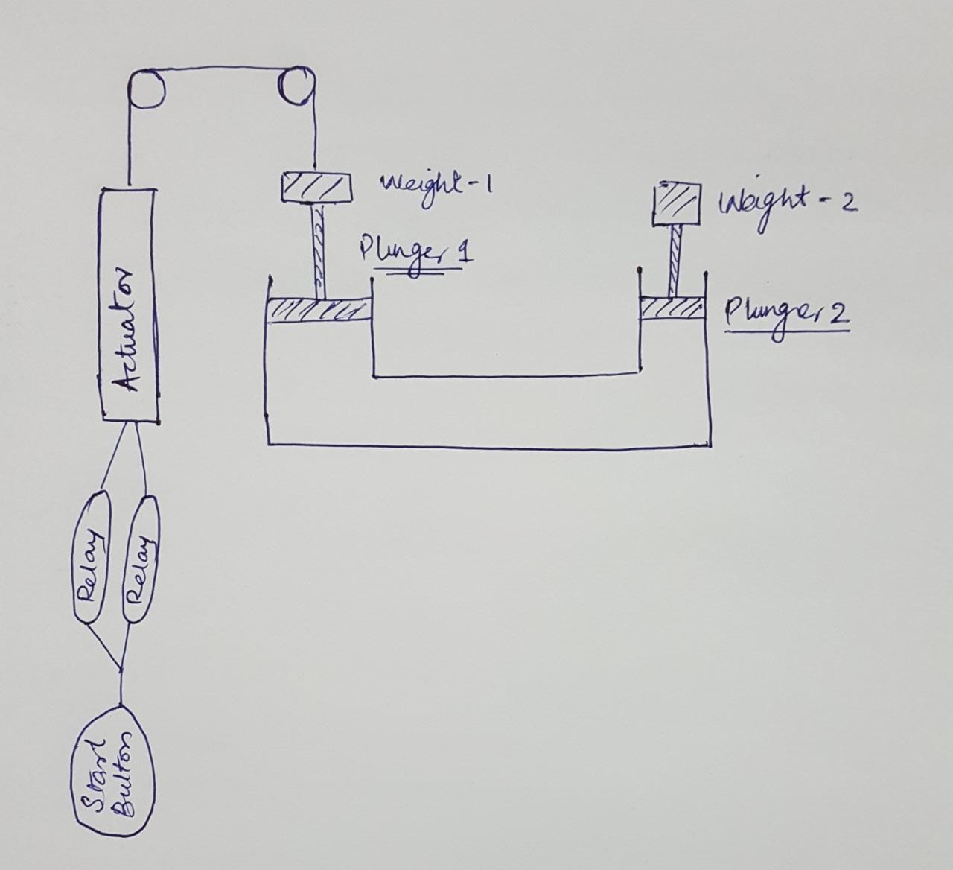

***Figure 20: Pascal Law***

## Design #8 Pulley and Link Mechanism

In this step the Plunger on right side rises which have the more weight “A” placed on it, in turn weight “B” which is lighter than “A” moves down. Both the weights are connected through a strips which passes through the pulley to reduce the frictional force. A string is attached to B as it moves down the string loosens which is used for switching on the next step. The schematic diagram of the pulley is shown in Figure 21.

.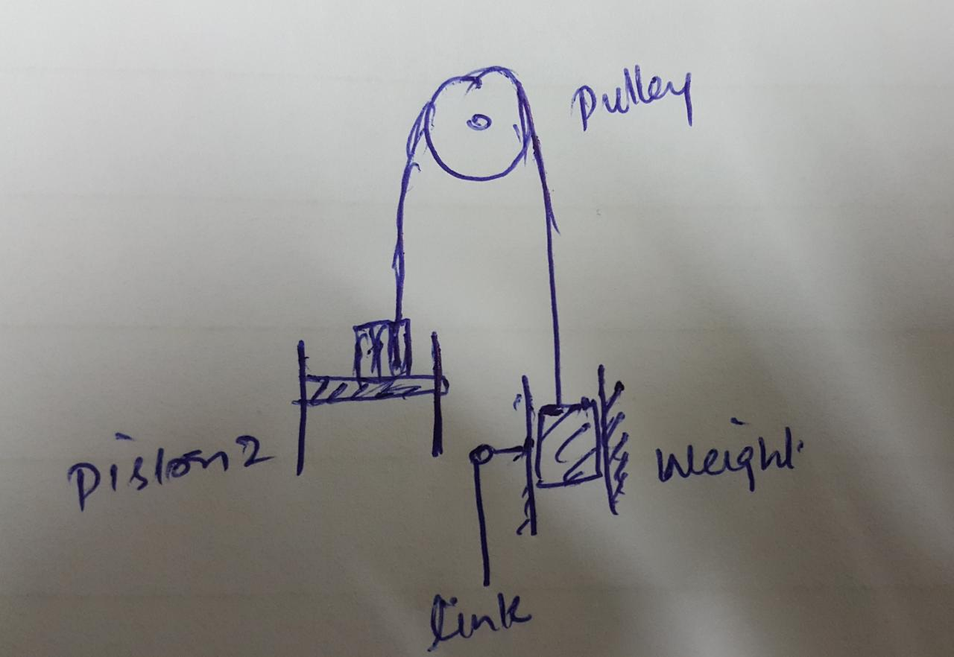

***Figure 21: Pulley Mechanism***

## Design #9 Gate Link Mechanism

In this step of RGM as weight B moves down, a thread attached to it will become loose to let the bridge down which allows the car to move forward for next step. The schematic diagram of the step in presented in Figure 22.

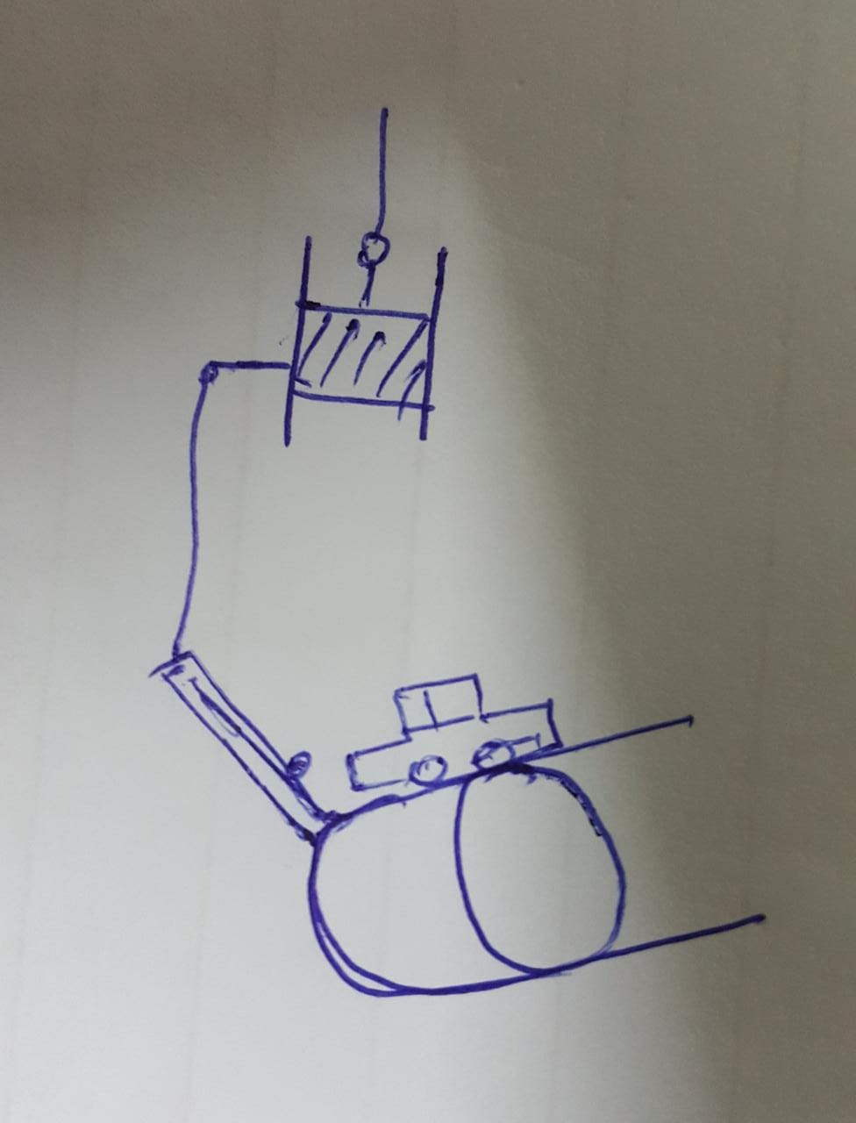

***Figure 22: Conveyer Belt Gate Link Mechanism***

## Design #10 Lever Mechanism

In the Step presented in Figure 23, the car falls on the left side plane of the lever mechanism. As a result, the weight on left side increases and becomes more than right so left side falls down while right rises. The plane on the lever is designed in such a way it will let a car to move when it falls down. Due to weight component acting along the bridge car changes direction at the same side when right side rises it pushes the button to turn off blower and to turn on Electromagnet in turn resetting dominos which ultimately reset the weight placed at the end. As the car leaves the lever, lever gets reset in its original position.

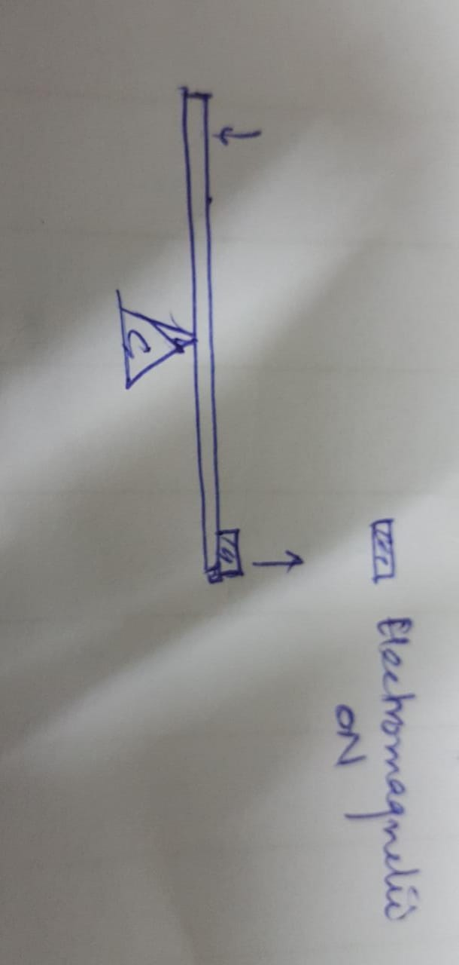

***Figure 23: Schematic diagram of Lever***

## Design #11 Lifting Mechanism

The car after leaving the lever will rush toward the lifting mechanism which is used to move it to its original position. The lifting mechanism will work on similar principle as the lift in building works. The car when moves toward Lift, it will hit the sensor installed which will turn on the drum motor and wire will be rolled on the drum resulting in the lifting of the car. The lift will be higher than the conveyer belt assembly. When the lift reaches a certain height, there would be stopper on one side as shown in Figure 24 which will provide inclination to the car to move out of the lift. When Lift reaches its peak position, the sensor installed there will reverse the motor drive and the lift will move down to its original position. After the car moves out of the Lift, there will be inclined ramp which to lead car to the original position at conveyer belt. This mechanism is shown in Figure 24.

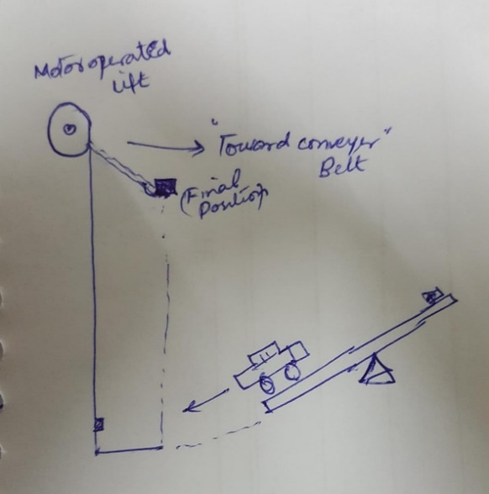

***Figure 24: Schematic diagram of Lifting Mechanism***

## Design #12 Chain and Sprocket Mechanism

The chain and sprocket mechanism play an important in resetting of the RGM. This mechanism is shown in Figure 25. This mechanism of chain and sprocket is driven by motor. It will move up the hair dryer and ball to its initial position. The hair dryer after performing its function comes to the end from which it will picked by the chain and sprocket. Similarly, the ball is also moved up after performing its intended purpose. The chain is provided with the two buckets, which has a size accordingly for ball and hair dryer.

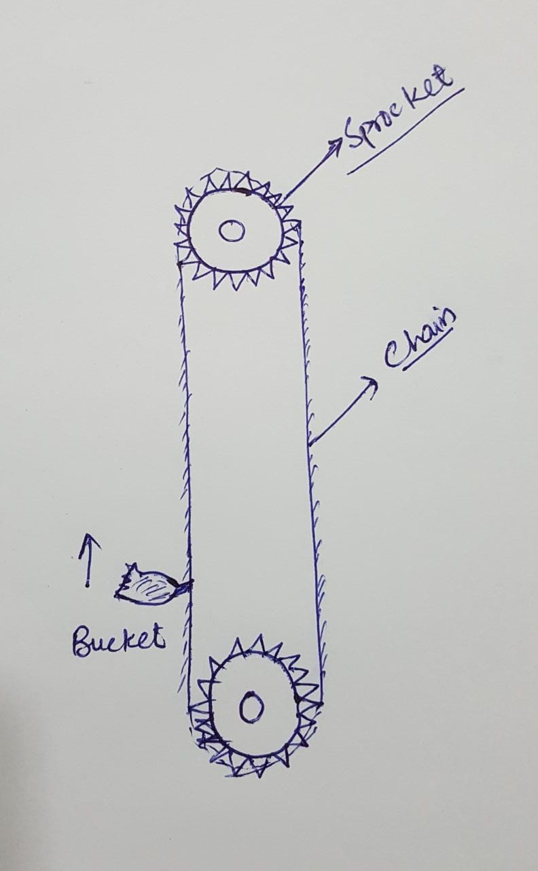

***Figure 25: Schematic diagram of Chain and Sprocket Mechanism***

# DESIGN SELECTED – First Semester

In this section, there is explanation of the criteria that was used so as to select the design that was the most appropriate. However, the decision is arrived at after a detailed analysis of various designs has been considered. The design which best fits the requirement of the client is chosen for the project. To arrive on this, the team made sure that they had critically analyzed all the components involved in the design to ensure it meets the all the needed requirements. Some of the major requirements achieved in the project included the needs of the customer which emphasized on coming up with a device that is reliable, unique, and efficient in its performance. The Rube Goldberg machine has several steps and hence we need to consider specific factors in the design by evaluating every individual step that will yield to the best design. The best of all the designs is then selected and presented in a schematic design as shown below.

## Rationale for Design Selection

The team used the Pugh Chart and Decision Matrix in order to select the most appropriate design for the project. The Pugh Cart was first used to narrow down the ten designs into the best four. Then from the four selected a design that meets most of the customer requirements was determined. However, the design which met most of customer requirements was set to be the datum [9]. The design which exceeded the datum in requirements was given a plus (+) and a minus (–) if it did not. In case of similarities, an “S” was given. At the end, a total sum of the (+), (–), and “S” was calculated below each design. The four best designs to be considered were the ones with the highest number of pluses. According to the Pugh chart above, the first four leading designs include: 1, 6, 7, and 8. The Pugh chart which was used is represented in the **Table 2** below.

**Table 2: Pugh Chart**

|  |  |  |  |  |  |  |  |  |  |  |  |  |
| --- | --- | --- | --- | --- | --- | --- | --- | --- | --- | --- | --- | --- |
| **CONCEPTS/ CRITERIA** | **Design #1** | **Design #2** | **Design #3** | **Design #4** | **Design #5** | **Design #6** | **Design #7** | **Design #8** | **Design #9** | **Design #10** | **Design #11** | **Design #12** |
| Efficient | - | + | - | - | - | + | + | + | + | + | - | - |
| Reliable | + | + | - | - | - | + | + | + | + | + | + | + |
| Easy to assemble | + | - | + | + | + | - | + | - | - | - | - | - |
| Self-resetting | + | + | - | - | - | + | + | + | S | - | + | + |
| Human integration | - | + | + | - | + | + | + | + | S | - | + | + |
| Easy to follow | + | - | S | S | S | - | - | - | - | S | S | S |
| Entertaining | S | - | - | - | - | + | S | S | S | + | + | + |
| Cartoon inspired | + | S | S | S | S | S | S | S | + | S | - | - |
| Durable | + | - | + | - | + | + | + | + | S | - | - | - |
| Self-Resetting | - | + | + | + | + | - | - | - | S | + | + | + |
| Ʃ+ | 6 | 5 | 4 | 4 | 4 | 6 | 6 | 5 | 3 | 4 | 4 | 4 |
| Ʃ- | 3 | 4 | 4 | 4 | 4 | 3 | 2 | 3 | 2 | 4 | 4 | 4 |
| ƩS | 1 | 1 | 2 | 2 | 2 | 1 | 2 | 2 | 4 | 2 | 1 | 1 |

The leading four designs selected from the Pugh Chart were further analyzed by use of a Decision Matrix. On the left-hand side is a list of customer requirements. They are then weighted depending on their significance on a scale of 1 to 5. In this case, 1 represents the design that is of less significance while 5 have the greatest significance. The rating was also on a scale of 1 to 5 whereby 1 shows least fulfillment and 5 the highest fulfillment. The rating was multiplied by the weighting and then added together to get the total score [10]. The detailed decision matrix is as shown in the **Table 3** below.

**Table 3: Decision Matrix**

|  |  |  |  |  |  |  |  |  |  |
| --- | --- | --- | --- | --- | --- | --- | --- | --- | --- |
| Criteria | Weight | **Design # 1** | | **Design # 6** | | **Design # 7** | | **Design # 8** | |
| **Score** | **WS** | **Score** | **WS** | **Score** | **WS** | **Score** | **WS** |
| Efficient | 5 | 4 | **20** | 3 | **15** | 4 | **20** | 4 | **20** |
| Reliable | 5 | 4 | **20** | 4 | **20** | 4 | **20** | 2 | **10** |
| Easy to Assemble | 4 | 3 | **12** | 3 | **12** | 4 | **16** | 3 | **12** |
| Entertaining | 4 | 4 | **16** | 3 | **12** | 5 | **20** | 4 | **16** |
| Carton inspired | 3 | 3 | **9** | 2 | **6** | 2 | **6** | 3 | **9** |
| Durable | 3 | 3 | **9** | 3 | **9** | 4 | **12** | 4 | **12** |
| Self-resetting | 4 | 2 | **8** | 3 | **12** | 1 | **4** | 3 | **12** |
| **Total** |  |  | **94** |  | **86** |  | **98** |  | **91** |

From the decision matrix, the design which appropriately fulfills all the client’s requirements is the **Design # 7**, i.e. Pascal Law with a score of 98.

## Design Description

The design that fulfill all the customer requirements has turned out to be the design # 7 i.e. Car on the inclined plane. The design is simple and entertaining. A hinged channel can easily be open and closed that make the step auto resettable. After selecting the design, the team has decided the dimensions of the step so that it can easily be fitted to the base of specified dimensions on the engineering requirement. After deciding the dimensions, the team has fabricated the prototype of some of the steps. The 1st step of this project is inclined conveyer belt system. The model of conveyer belt system is shown in **Figure 26.**

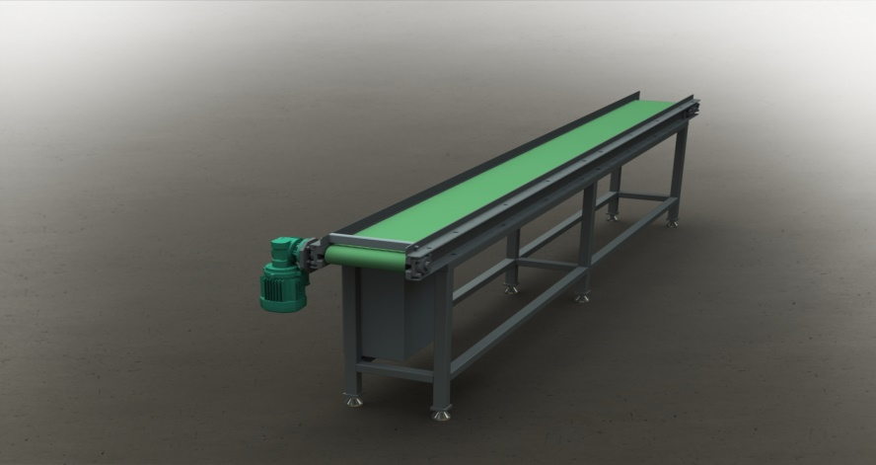

***Figure 26: Conveyer Belt System***

**Figure 27** represents the plunger which can easily be assembled in sequence to trigger the mechanism of plunger from the pulley system. As can be seen from the figures the weights are attached to both ends of the pulley with the thread. As the weight of the left side start moving upward, the weight attached to the right of pulley will fall down on the plunger. The Kinetic Energy and potential energy of the weight will apply the pressure on the air contained in the pipe assembly which will actuate the other side of the plunger. Due to which the plunger will start moving upward which can be utilized in triggering the next step.

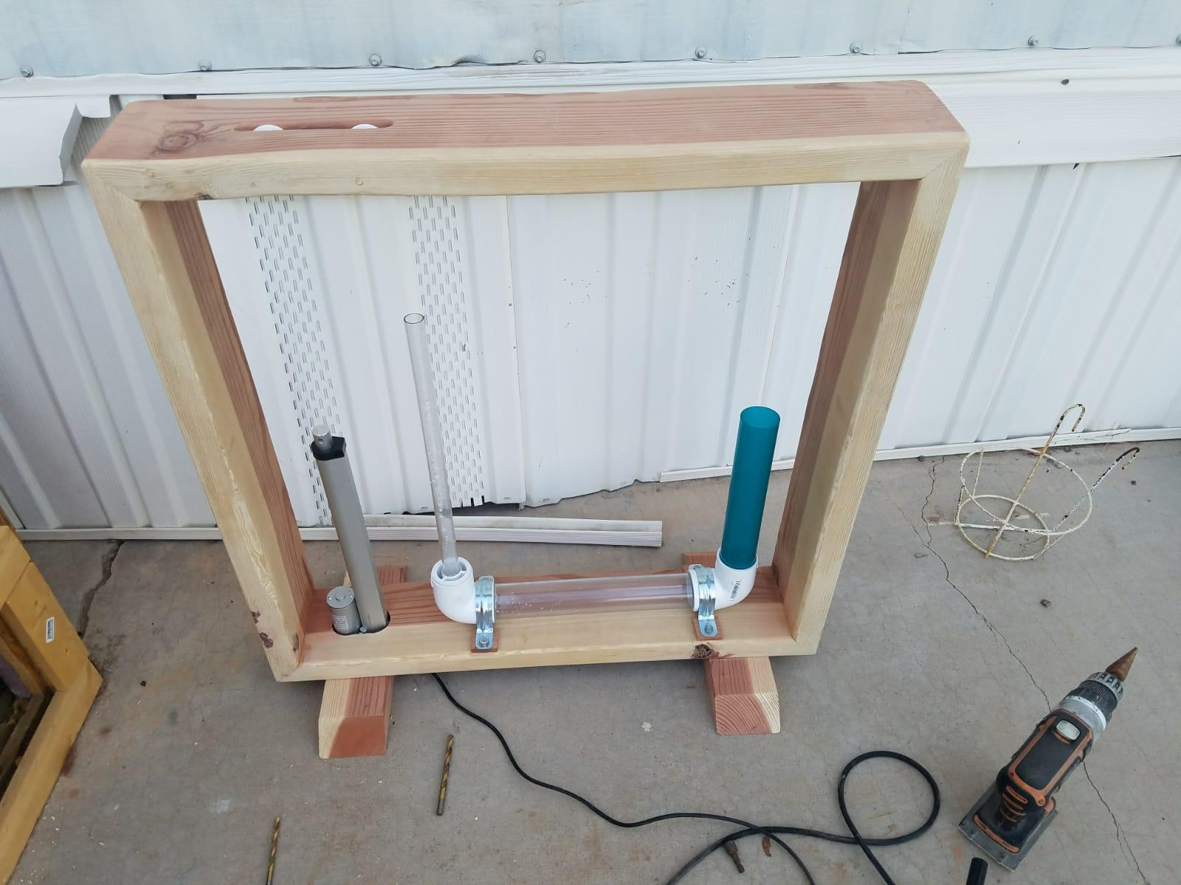

***Figure 27: Pascal Law Equipment***

**Figure 28** represents a ramp on which a ball is placed on the ramp. As the stopper is removed by the human, the ball will start rolling on the ramp. The ramp is designed in the multiple steps to increase the complexity of the step. The Kinetic Energy of the ball can be utilized to trigger the following step. It can also be used as the starting step as it requires human interaction.

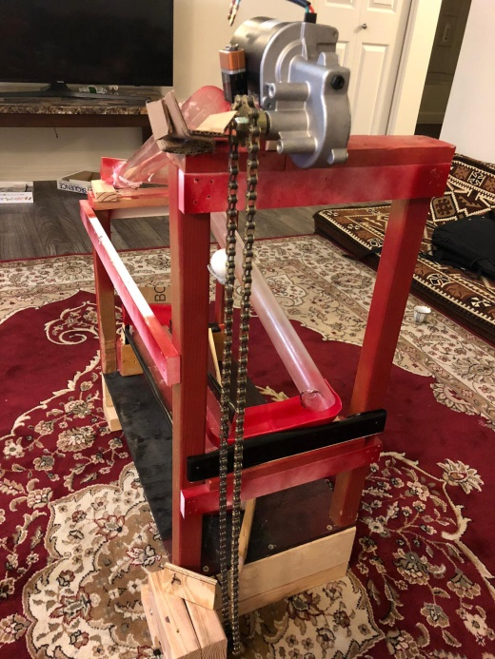

***Figure 28: Ramp and Sliding Door***

The individual parts of the steps and the material that has been selected is as below-

1. **The base of prototype:** Wood is used for making the base of the prototype.
2. **Ramp:** Ramp is fabricated by utilizing the waste plastic and silver foil box.
3. **Ball:** Steel Ball to get the desired momentum.
4. **Pulley:** Plastic due to cost effective.
5. **Weight:** Steel due to its higher density and less size.
6. **Channel for guiding the motion of the Car:** Plastic since it is not bulky and offers minimal friction
7. **Car:** A toy car of plastic since it is easily available in the open market and it is not costly
8. **Hinge:** Plastic and a steel wire, Due to the strength and durability

The prototype will be made in order to evaluate its performance.

### Theoretical Analysis

Theoretical analysis is necessary to determine the parameters of the parts to be used in order to get the desired outputs. Theoretical analysis of all the steps are presented in the following sub-sections.

#### 5.2.1.1 Pascal Law (Ali Almari)

This device will demonstrate Pascal's Law which states; a pressure change at any point in a confined incompressible fluid is transmitted throughout the fluid such that the same change occurs everywhere [23].

The device will be U shaped using three sections of pipe and two elbows. One side of the pipe will be much larger than the other side. The bottom pipe will be the same size as the larger side. It will be filled with water with plungers to trap the water on both sides.

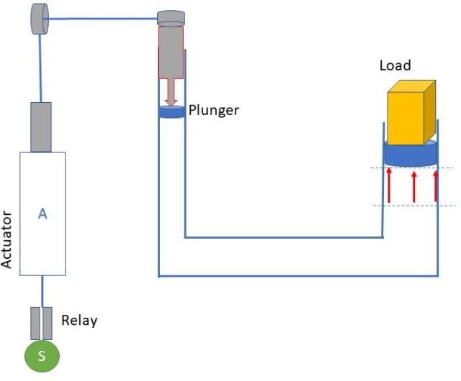Because the surface area on the larger plunger is 5.7 times greater than that of the small plunger when force is applied to the small plunger it is multiplied by 5.7 creating a multiplied advantage of force.

***Figure 29: Design Schematic of Pascal Law***

The schematic diagram of Pascal law is shown below:

RELAY

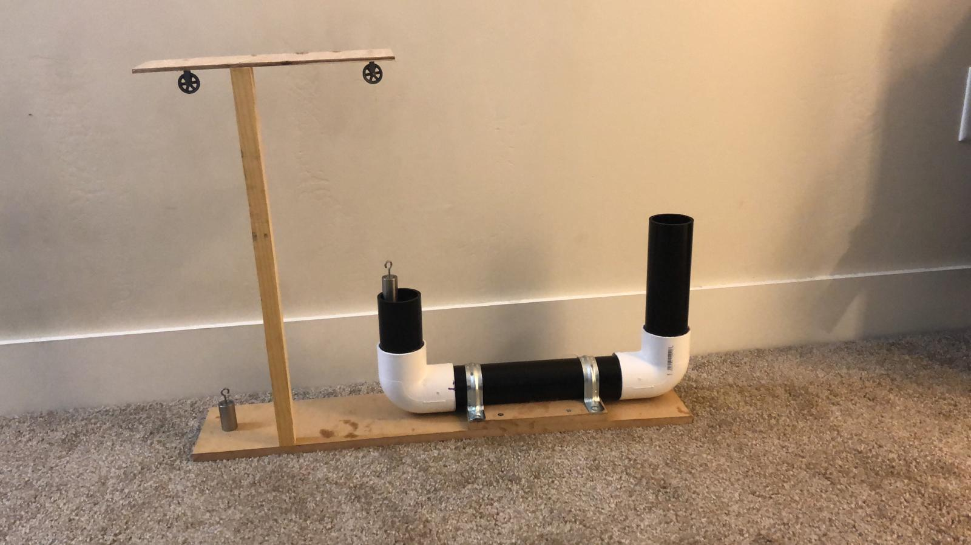

WEIGHT

ACTUATOR

Start Button

RELAY

There will be a small weight on the small side and a larger weight on the larger side (up to 5.7 times larger) that are attached to each plunger. An actuator will be mounted parallel to the small side pipe. It will have a string or rope attached that will go through two pulleys that will connect it to the small side’s plunger. When the actuator goes up the weighted plunger on the small side goes down when the actuator goes down the plunger goes up [24].

The CAD model of Pascal Law mechanism has been shown in Figure 27:

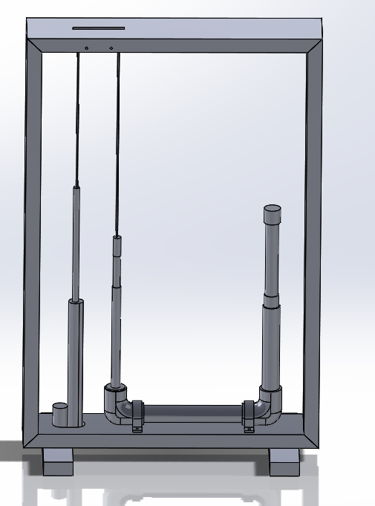

***Figure 30: CAD Model of Pascal Law Mechanism***

Area of the large plunger:

$$A_{1}=πR^{2}= π×{0.95}^{2}=2.83 {in}^{2}$$

Area of the small plunger: $$A_{2}=πr^{2}= π×{0.4}^{2}=0.5 {in}^{2}$$

The ratio of cross-sectional areas is given by:

$$\frac{A_{1}}{A_{2}}=\frac{2.83}{0.5}=5.7$$

The device will function with the press of a button and automatically reset itself. When the button is pushed it will send a signal or trigger to two separate relays. They will be programmable relays. One will be programmed to immediately extend the actuator. This will allow the weighted plunger to apply a downward force into the liquid. It will then cause the larger plunger to rise on the other side. Then once the actuator is fully extended the second programmable relay will then retract the actuator back to its original position. At this point the left smaller side will go back up. And the right side will go back down.

The following are the calculations for the Pascal’s Law:

The project is incomplete, and a lot of work is yet to be done to ensure that the design that we picked is optimum. In future, we would like:

* To build and test the system with different lengths of PVC pipes to see what effect it has on the forces.
* Test the system with different weights.
* Test the system with different types of relay switches to determine which one offers the fastest response.
* Test the system with different types fluids, so to see the effect compressibility has on the functioning of the system.
* Test the system with different types of actuators so to see which one fits our system the best.

#### 5.2.1.2 Conveyer Belt (Omer Aldhafeeri)

The belt conveyors are used for conveying and transporting different material from one place to the other within a work place. Mostly used as an automated conveying elements in the production line. In this mini project we are supposed to design a portable conveyor belt system that can transport an object of 365 grams through 32 inches on a horizontal plane. The design of belt conveyor system typically involves the selection of different electronic and mechanical part based upon the requirements such as electric motors, the idlers, and the belt and micro controllers to be used. This document will cover all the basic calculations involved in the design of belt conveyor system that can best do our job [21,22].

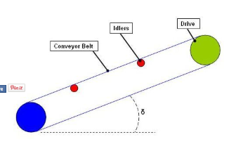

***Figure 31: Conveyer Belt Equipment***

The basic calculations for the design of conveyor belt mechanism involve:

* Belt Tension
* Load Due to Idlers
* Power at Drive Pulley
* Starting Belt Tension
* Motor Sizing and Selection
* Acceleration
* Belt Breaking Strength

Now we will calculate the above-mentioned parameter one by one to design our mechanism within the given design constraints.

* **Steady State Belt Tension**

The belt of a conveyor always experiences a tensile load due to the torque from electric drives, the idlers and the load of conveyed object. Let’s calculate the belt tension from the expression given as:

$$T_{b}=1.37fLg\left[2m_{i}+\left(2m_{b}+m_{m}\right)\cos{δ}\right]+\left(Hgm_{m}\right)$$

Where $f$ represent friction between belt and pulley, *L* is the length of conveyor, g is the gravitational acceleration, $m_{i}$ is load due to idlers, $m_{b}$ is the load due to belt, $m_{m}$ is the load due to object, *δ* is the inclination angle and H is the height of conveyor

Now using the given design constraints, we have;

$f$ = 0.02

*L* = 32 inches = 0.8 m

*g* = 9.8 ms-2

= Negligible

$m_{b}$ = 5 kg/m

$m_{m}$ = 0.365 kg

*δ* = 0 rad

$H$ = 0

We have by putting all the values in equation given above, belt tension “ $T_{b}$” become 2.22 N.

* **Power at Drive Pulley**

Since the belt tension has been calculated let’s move towards power at driven pulley.

The power at driven pulley is given by:

$$P_{p}= \frac{(T_{b}V)}{1000}$$

Where $P_{p}$ the power at driven pulley in kW is, $T_{b}$ is the belt tension in Newton and $V$ is the belt speed in m/s. The given values are:

*V* = 1 m/s

$T_{b}$ = 2.22 N

Hence by putting all values, we get $P_{p}$ as 2.22 W.

* **Starting Belt Tension**

Initially the belt tension will be much higher when it starts due to start up factor. Thus, the starting belt tension can be calculated as:

$$T_{bs}= T_{b}×K_{s}$$

Where $T_{b }$ is the steady state belt tension, in Newton and $K_{s}$ is the startup factor.

Putting all the values with startup factor as 1.5, we get the starting belt tension as 3.33 N.

* **Motor Sizing and Selection**

The minimum motor power can be calculated as:

$$P_{m}= \frac{P_{p}}{K_{d}}$$

Where $P_{p}$ is the power at drive pulley and $K_{d}$ is the Drive efficiency.

Inserting all the given parameters in above mentioned formula with drive efficiency as 90%, we get the minimum required motor power as 2.46 W.

* **Acceleration**

Acceleration of conveyor belt can be calculated as:

$$A= \frac{\left(T_{bs}-T_{b}\right)}{\left[L×(2m_{i}+2m_{b}+m_{m})\right]}$$

Where $T_{bs}$ is the starting belt tension in N, $T_{b}$ is the steady belt tension in N, $L$ is the length of the conveyor, $m_{i}$ is the load due to the idlers, $m_{b}$ is the load due to belt and $m_{m}$ is the load due to the conveyed materials. By putting all the known values, we get acceleration as

**A= 0.129 ms-2**

* **Belt Breaking Strength**

This parameter determines the selection of belt. The strength of belt determines the load at which the belt will fail. So, it’s very important for the safety of the system:

$$B_{s}=\frac{\left(C_{r}P_{p}\right)}{(C_{v}V)}$$

Where $C_{r}$ is friction factor, $C_{v}$ is the Breaking strength loss factor, $P_{p}$ is the Power at drive pulley and $V$ is the belt speed. The value of $C_{r}$ is 15 and $C_{v}$ is 0.75 which will result in belt breaking strength of 44.4 N.

#### 5.2.1.3 Hair Dryer (Jassem Alhaddad)

For this specific project, the aim is to demonstrate how a hair dryer can be used at the end of the Rube Goldberg where it will suspend a tennis ball on air while it is on. The Hair dryer is shown in the Figure 32.

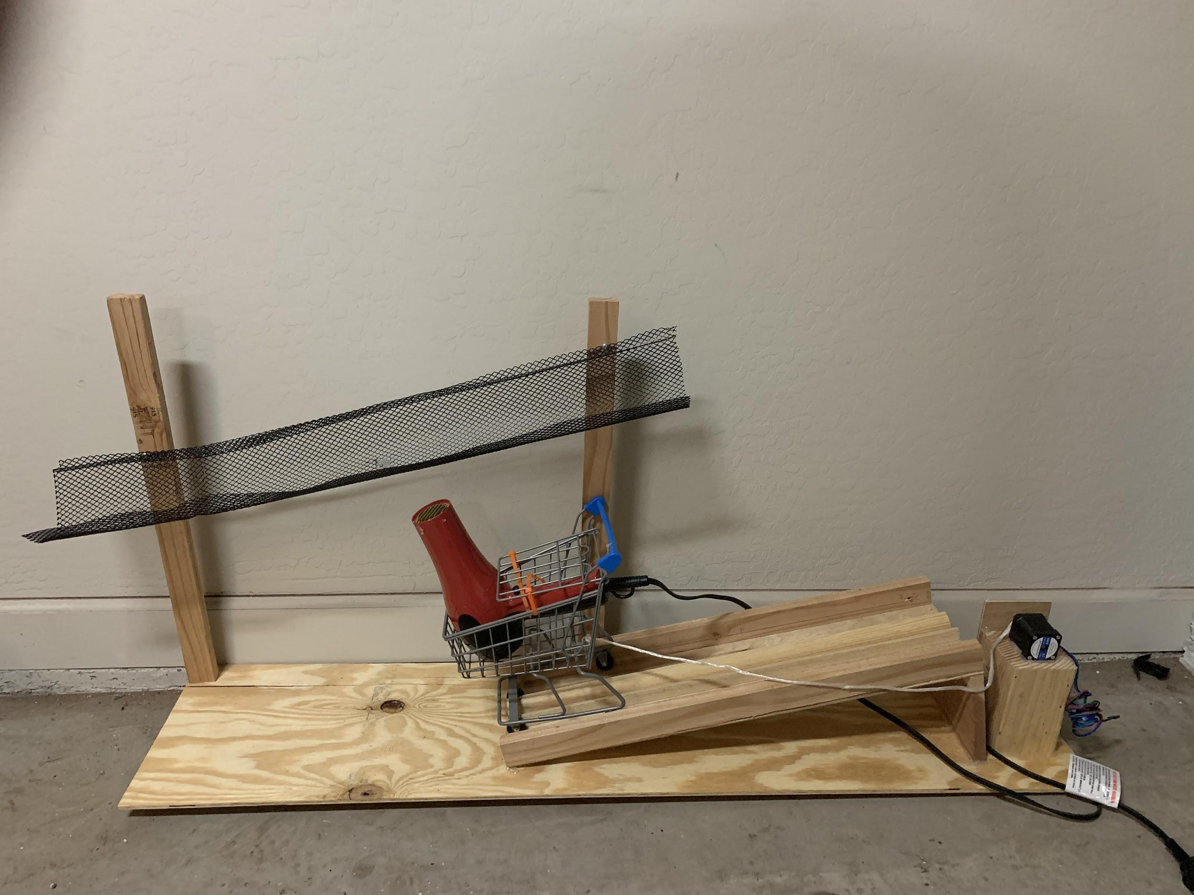

***Figure 32: Hair Dryer***

The force of gravity acts on the ball opposing its upward push. Consequently, as the ball moves up, it gains potential energy due to its elevation. Due to the law of conservation of energy the increase in the potential energy is as a result of the transformation of the kinetic energy. Specifically, the gravitational pull on the ball causes a reduction in its velocity. By the time the ball reaches the maximum height, the initial velocity will have reduced to zero hence reducing the kinetic energy to zero. At this point the kinetic energy will have transformed to potential energy fully. The ball therefore stays within the air column because the forces acting on it balance (force due to air pressure and the force of gravity). According to Bernoulli’s equation, since the air coming from the dryer is moving faster than that around the ball, it has a lower air pressure. In this case, the ball remains within the column where there is lower air pressure due to the higher pressure acting around it.

The power rating of the hair drier determines the velocity of air exiting the device concerning the equation below:

𝑃 = 𝑇 × 𝑉

Where T is the torque of the air motor, and V is the terminal velocity of air as it leaves the nozzle of the hair drier. The torque of the air motor is dependent on the number of coils in the armature winding and the quantity of current flowing into the device from the power source.

Current is proportional to the voltage of the power source with respect to resistance, as shown by the equation below:

$$V=IR$$

The above equation shows that the velocity of air can be controlled by controlling the resistance in the device. This can be achieved by including a variable resistor to the circuitry of the system to provide a way of directly controlling air velocity.

The angle of the slope of the ramp determines the velocity of the cart. This is because it influences the amount of gravitational pull acting on the cart. If the angle is for instance 30° from the horizontal, the total gravitational force acting on the cart would be given by:

$$F=mg \sin{{30}^{°}}$$

The movement of the cart along the is retarded by friction with the ramp surface; hence, the velocity of the ramp can be controlled within certain limits by making the ramp surface smoother or rougher. The Rube Goldberg machine designed can achieve control action by using pressurized air to hold a ball afloat. The system comprises of a hair drier, a ramp, a ball, and a power source. The key factors directly influencing the functionality of the system include the mass of the ball, the power rating of the hair drier, and the angle of inclination of the ramp. The coefficient of friction of the ramp surface also plays a small part.

#### 5.2.1.4 Lever Mechanism (Mohammed Abanaqi)

The team will be focusing on the manufacturing of a system consisting of a movable part in the shape of a small gate. This gate moves up under the influence of potential energy. This gate has primary function of stopping the ball from moving in the forward direction. During the experimentation one of the main problem is the landing position of can ball or the car, they drop on the right side of the lever where there is a cup placed. On the other hand, the weighted body is supposed to fall on the left side of lever to move the car and the ball. The lever is shown below:

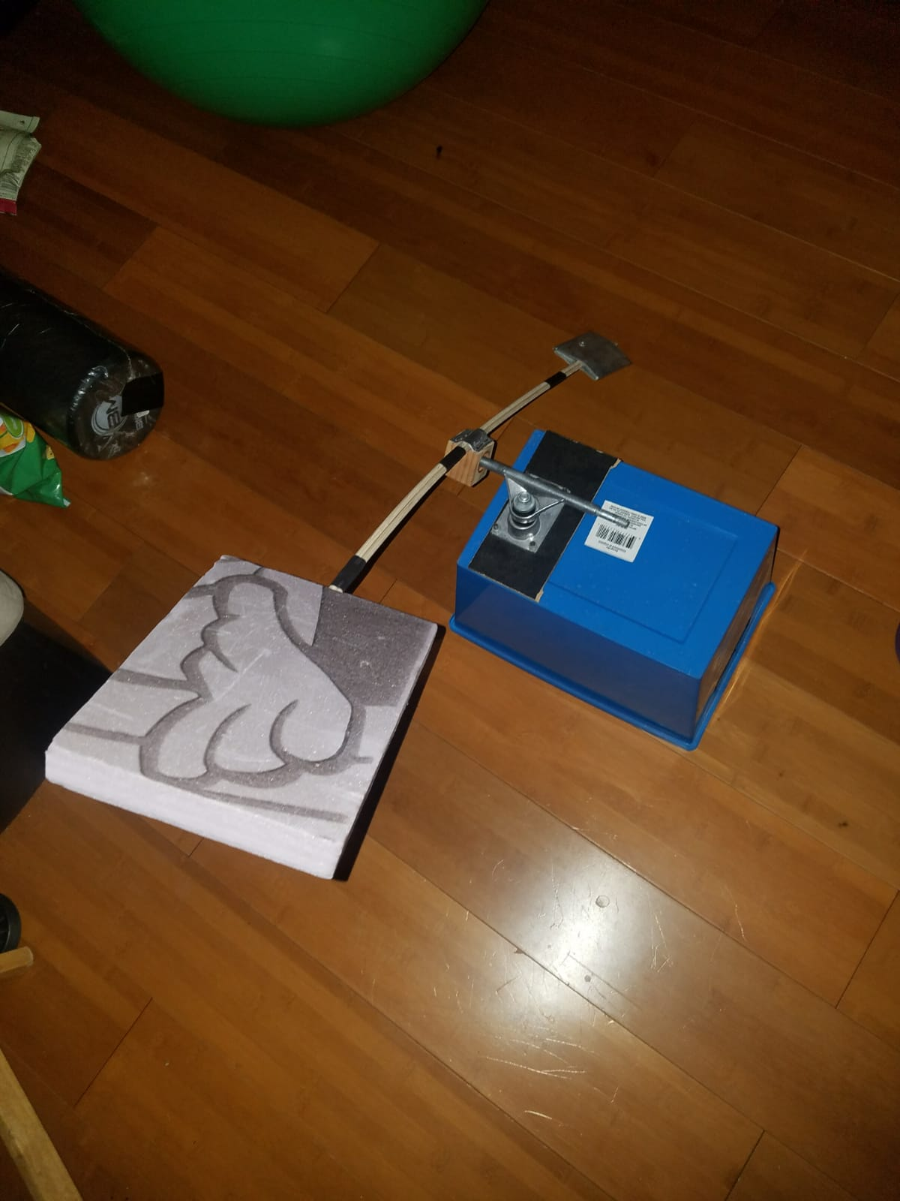

***Figure 33: Lever Mechanism***

The term “work” refers to the energy transfer when an external force moves an object over a given distance. The work (W) done by a constant force on the ball can be expressed as a product of the force along the direction of displacement (Figure6):

$$W=\left(F\cos{θ}\right)∆x$$

Multiple forces act on the ball, the total work is a sum of the work done by each individual force:

$$W_{net}=\sum{W_{F_{i}}}$$

Since work is a scalar quantity, the algebraic sum can be expressed as follows:

$$W_{net}=W_{g}+W_{N}+W_{F}=\left(F\cos{θ}\right)∆x$$

The kinetic energy associated with the motion of the ball used in this step is expressed as:

$K.E=\frac{1}{2}{mv}^{2}$ [15]

The ball has a mass of 50g and the K.E. is 360, then the velocity of the ball becomes14.4 m/s.

The total mechanical energy of the system can be extended to include spring potential energy. The total mechanical energy of the system can be expressed as follows:

$$E=K.E. +P.E. +P.E_{s}$$

Also, the total mechanical energy of the system is conserved, which is given as:

$$\frac{1}{2}{mv_{i}}^{2}+{mgy_{i}}^{2}+\frac{1}{2}{kx_{i}}^{2}=\frac{1}{2}{mv_{f}}^{2}+{mgy_{f}}^{2}+\frac{1}{2}{kx_{f}}^{2}$$

#### 5.2.1.5 Sliding Door/RGM (Abdullah Alsayeh)

This RGM project entails the fabrication of four ramps. They are curvy in shape to increase the moment of the ball as it falls or slides on the slopes. Each system integrates a gear chain and a sprocket on the ramp that returns the ball to its original position.

Efficiency is a contemporary issue in work and energy theorem. Thus, the RGM integrates the mechanical advantage of a chain, a ramp, and sprockets into its design to address energy efficiency. For this reason, it finds wide applications in the state-of-the-art facilities, such as sailing/fishing boats, cranes, bicycle chains/rings, and elevators. Engineers integrate motors and electronics into such application to reduce power consumption and simplify tasks, hence reducing human effort.

The RGM built from real mechanical components is powered by a DC motor hooked to a battery. Equally, two interchangeable motors can be used. However, the applicable analytical calculations pertain to the chain and sprocket selection and design. Thereafter, the model will be calibrated in the lab to test its performance. Aluminum and steel as the most sought materials for chains and sprockets. Although aluminum is more attractive and lighter, steel was selected for this project. In essence, the material is more affordable and stronger than aluminum [28]. Typically, a steel sprocket is best selection for longevity and durability purposes. Thus, for the rear sprocket, the steel was induction-hardened to increase its toughness, resilience, and durability.

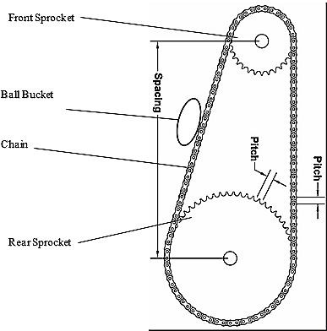In the event of a misalignment, the chain and sprockets may undergo extensive wear when the distance between the two working sprockets is extremely narrow. To render the alignment less damaging, the ball bucket is positioned at least 80 mm from the front and rear sprockets. From the economics point of view, a smaller diameter shaft is preferred to a larger one. The selection minimizes costs on material expenditure. Moreover, the size allows for a low-cost, component upgrade with a tougher material if need be [25]. However, a smaller pitch diameter experiences larger reactive forces than the remaining components of the assembly. Still, even the ¼ inch-diameter is acceptable, provided it can withstand the stall torque of the DC motor.

***Figure 34: Chain and Sprocket Mechanism***

Table 4 summarizes the technical specifications for the applicable sprocket hub diameters and pitch sizes [26].

**Table 4: Chain and sprocket selection**

|  |  |  |
| --- | --- | --- |
| Pitch Size (P)  Meters | Roller Diameter (Dr)  meters | Chain # |
| 0.006 | 0.003 | 25 |
| 0.010 | 0.005 | 35 |
| 0.013 | 0.008 | 41 |
| 0.013 | 0.008 | 40 |

For a project of this scale, the ideal chain number is # 25, where Dr = 0.003 m and P = 0.006 m. The clearances required to permit smooth interaction between the sprocket teeth and the chain rollers is determined by the radius of the topping curve R and the seating curve diameter Ds[26,27]. These parameters are computed by equations (1) and (2) for a sprocket with a number of teeth N.

$D_{s}$ = 1.0005 $D_{r}$ + 0.003 = 6.0015× ${10}^{-3}$ m

$\frac{D_{s}}{2}$ = R = 0.5025 $D_{r}$ + 0.0015 = 3.0075× ${10}^{-3}$ m

The factor of safety or safety coefficient (SC) of chains and sprockets is maintained between 7 and 10. However, it can be modified for a variety of usage conditions, such as loading conditions and chain speed [5]. It is calculated by equation (3).

$$SC=\frac{Strength of the Material (MPa)}{Maximum Load Applied (N)}$$

For this project, an SC value of 8 corresponds to a chain speed of 25 ~ 50 revolutions per minute (RPM) is recommended.

Overall, this project has equipped me with detailed knowledge regarding the design of complex systems. The ramp is simply an electrical-mechanical system designed to automate tasks.

#### 5.2.1.6 Cam and Dominos Device (Ali Alrashidi)

This step is important in this project because it will make many steps reversible, so it starts once the hammer hits down the nearest domino piece that will fall and hit the other domino piece next to it and the other and the other as an expected motion from its designed momentum – the literal domino motion effect. While the six domino pieces are setting in motion, the hammer will then return to start position using motor. The domino pieces will be placed with hinges at the bottom, hence, the motion of the fall will be towards the right side and the last domino piece, which will be heavier three (3) times from its original weight, will push the plunger that will activate the pulley, leading towards the expected motion for step five (5). The heavier weight dominos is set on a button which will activate a motor to pull the dominos back to their original place.

The materials identified on this step includes motors device, domino tiles, the hammer, and metal hinges. The motor used in this project is a stepper motor Bipolar. For each step, a stepper motor will serve different purpose. The first stepper motor will pull the fish lines attached to dominos and then release the line to make the dominos to fall again. The second stepper motor will make cam to rotate and press the tangential spring attached to the hammer and gives the hammer enough force to hit the dominos. Since, this project needs two stepper motors, dual motor driver is necessary to run these motors and control their motion based on code compiled in Arduino device. The power needed to run dual motor driver came from plug adapter to convert AC power supply to DC power supply to run the motor safe.

For this project, the domino tiles will be made up of plastic, which the materials are commonly made of. Plastic materials have the properties of engineered material that is made from an expansive scope of natural polymers. It is lightweight with high durability to mass, waterproof, shockproof, and non-conductor of heat and electricity. Aside from the domino tiles, the hammer that will be used as initiator of the machine will also be made of plastic since rubber ball will deviate a different calculation of motion as expected for the machine. Plastic hammer is less bouncy and lighter; hence, it will be suitable for some of the sensitive plungers and indicators placed on the machine.

The location of this component within the entire system of the designed Rube Goldberg Machine is due to the design of the prior steps, particularly when the hemmer has to roll down from the dominos, and by doing that the force created by the hammer will serve as the kinetic force that will initiate the motion of the falling domino tiles by hitting the first domino tile. The purpose of the falling tile is to pass on the kinetic force by also hitting something that will initiate the next action to complete the course process, which is the plunger.

The variable identified on this step includes the mass of the hammer and the mass of the domino tiles. The ideal size of the hammer for this project is larger to the size of the normal hammer with size that cannot be smaller or bigger to 2 x 4 inches or 3 x 5 inches square hammer. Considering elastic collisions equation in X-direction to calculating the force needed to let dominos to fall by a hammer with the needed speed after and before the collisions is the given by:

$m_{1}$ is hammer mass.

${v_{1}}^{'}$ is velocity of hammer after collision

$m_{2}$ mass of the dominos

${v_{2}}^{'}$ is velocity of dominos after collision

$v_{1}$ is velocity of hammer before collision

$v_{2}$ is velocity of dominos before collision

The conservation of momentum is calculated by,

$$m_{1}v_{1}=m_{1}{v_{1}}^{'}+m_{2}{v_{2}}^{'}$$

The conservation of kinetic energy is calculated by,

$$\frac{1}{2}m_{1}{v_{1}}^{2}= \frac{1}{2}m_{1}{v_{1}'}^{2}+\frac{1}{2}m_{2}{v_{2}'}^{2}$$

The hammer weight is 0.25 kg, the speed impact will be 3.13 m/s or 11.27 km/h with time until impact of 0.32 s using constant speed equation,

$$v=\frac{x}{t}$$

The energy at impact of 2.8 joules. The motion of the fall of the domino tiles is also relative to the speed of the course of the machine function.

Considering the same equation, where the domino tiles will be approximately 0.108 meters in height and its weight is approximately 0.05 kg in mass, the speed impact will be 3.16 m/s or 11.36 km/h with time until impact of 0.32 s and energy at impact of 1.2 joules.

For snail cam design these are the equations needed to find the variables [31],

$φ$: the rotary angle of the cam measured from the beginning of the motion event.

$β$: The range of the rotary angle corresponding to the motion event.

$h$: the stoke of the motion event of the follower.

$S$: Displacement of the follower.

V: Velocity of the follower.

A: Acceleration of the follower.

When

$0≤φ≤\frac{β}{2}$

$$S\left(φ\right)=2h\frac{β^{2}}{φ^{2}}$$

$$V\left(φ\right)=\frac{4h}{β^{2}}φ$$

$$A\left(φ\right)= \frac{4h}{β^{2}}$$

When,

$$\frac{β}{2}≤φ≤ β$$

$$S\left(φ\right)=h-\frac{2h}{β^{2}}{(β-φ)}^{2}$$

$$V\left(φ\right)=\frac{4h}{β}(1-\frac{φ}{β})$$

$$A\left(φ\right)= \frac{4h}{β^{2}}$$

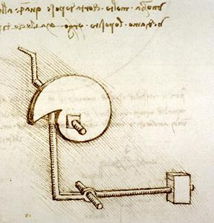

***Figure 35: A snail cam invention of Leonardo Da Vinci [30]***

This particular component of the machine is designed to be short to easily pass on the intended action leading to step five (5) and the rest of the steps until the original aim is completed. Also, this is the step where a reverse action to the ball will take place in order to prepare the machine for the next entire routine, and for the tiles to be risen again after falling down to the intended direction. Overall, there are three (3) short intended goals that this step needed to achieve – for the last domino tile to press the plunger, for the hammer to return to its original place, and for the fallen tiles lifted back by stepper motor.

# PROPOSED DESIGN – First Semester

The sequential manner to achieve the specified goal. The inclined wedges will be made from the plastic sheets which are glued to the wooden plank in order to increase the stability and weight. Each team member has chosen to build the prototypes of the multiple different steps. All the ten steps will be fabricated, and testing will be done to ensure the reliability and durability of the steps. After testing all the prototype, the team will make the modification if necessary, to improve the steps reliability and durability. After the modification all the steps will be arranged in a sequence on a single platform to perform the assigned task. After arranging the steps, self-reset ability will be verified, and this may also result in introduction of some supporting steps to the main steps of the prototype. The team will ensure that all the individual steps are self-resettable. Post arrangement of the steps of RGM, the team will run the machine multiple time to test the RGM based on the engineering requirement. Finally, the team will show its RGM to the audience and will record the feedback. A detailed schedule of implementation task is placed in **Figure B.1** at **Appendix B**. It represents the timelines in which a specified task needs to be completed. It will help us in fabricating the RGM within the specified time.

## Resource Utilized

The team has listed all the resources which needs to be utilized for successfully designing and fabricating the RGM. The resources include the human, manufacturing facilities and space. All the resources have been presented in Table 5.

**Table 5: Resource List**

|  |  |  |  |
| --- | --- | --- | --- |
| Resource Category | Resources | Location | Expertise |
| Technical Advisor | Dr. David Trevas | NAU | Instructor |
| Human Resource (Team) | Ali Almari | NAU | Student |
| Abbdullah Alsayeh | NAU | Student |
| Mohammed Alanaqi | NAU | Student |
| Ali Alrashidi | NAU | Student |
| Omer Aldhafeeri | NAU | Student |
| Jassem Alhaddad | NAU | Student |
| Suppliers | Homco | Flagstaff, AZ | Hardware Shop |
| Home depot | Flagstaff, AZ | Lumber and Hardware |
| Walmart | Flagstaff, AZ | Outlet |
| Amazon | Online Shopping | Hardware |
| Self | Self | Step Fabrication |
| Facilities | Build Space | NAU engineering Lab | Part Manufacturing |
| Engineering Building of NAU | NAU Facility | Review Meetings |
| Carpenter Shop | Home Depot | Part Manufacturing |

## Bill of Material and Budget Cost

The detailed bill of material is presented in the Table C.1 at Appendix C. The table includes the source of the material as well as cost of each material. The total expenditure made for fabricating the prototype is approximately $169 which is only 11.2% of the total budget cost. The research is being made during the finalization of the source of material to minimize the cost of the project. Total estimated cost of the project is estimated as below in Table 6.

**Table 6:** Estimated Cost of RGM

|  |  |
| --- | --- |
| **Particular** | **Estimated Cost ($)** |
| Material Cost till date | 445 |
| Material cost during modification and addition of steps to increase the reliability | 130 |
| Fabrication Cost (Wood Work) | 400 |
| Labor Cost | 50 |
| Miscellaneous items (Adhesives, Papers, paper plates and material to increase the aesthetic etc.) | 50 |
| **Total** | **1075** |

Total estimated cost of the RGM has been worked out to be $1075 which is well below the required cost of the project ($1500).

# CONCLUSION

The project is undertaken successfully, and it is designed according to the plan of conception. The different design models, which are involved in the RGM, are in manufacturing phase. The material is purchased for the said purpose and it is assembled as per design requirements. The design and manufacturing processes of this project shows that material quality is one of the most fundamental consideration of every project. However the two special events in the design could have brought up various failures in the operation of the machine.

## Design Changes

Initially there were ten steps involved in the design process which is increased to twelve in order to improve the system. These steps are added to make it resettable and more entertaining, which are requirements for the customer requirement. Each student will take two steps of design which will be dependent on their compatibility and functions.

The design steps involved are modified accordingly to implement the manufacturing of the model. The CAD models are developed to explore details involved in the manufacturing of the product. In the previous work, the resettable steps were ideally designed but there were some manufacturing constraints in its productions. These steps are modified to make it more realistic. The best design was selected after going through a list of alternatives and considering various factors such as the cost of production and reliability

## Project Outcomes

The success of the project owes to various factors considered during the project design. During the design and manufacturing process of the project we learnt that proper planning is necessary to come up come up with the conceptualized idea. After the idea conceptualization, it was necessary to come up with a sketch of the machine that would help to save on time when coming up with the real thing. The team came had different backgrounds and this incorporated positive aspects of diversity into the design and production of the project. On the other hand, owing to the complexity of the design some aspects of trial and error were used as part of the project procedures. While the project achieved its purpose by offering a beneficial opportunity of exploring physical realizations to come up with abstract concepts, we felt that it would be easier to manufacture the machine if a model was first drawn before designing the whole machine. This would help to identify some potential pitfall on the design before the actual implementation. Also, there were suggestions that the project should have a better structure that will make the students time more effective. It should incorporate some trainings on the on the shop work basics which will highly boost the productivity of students with little experience on building and construction. Also, if the project were to be made part of the courses the institution needs to dedicate more resources on the supply of materials that will be used by the students for their projects hence a better facilitation of their construction processes.

# REFERENCES

1. Digital Trends. (2019). Feast your eyes on the wildest, most elaborate Rube Goldberg machines ever built. [online] Available at: https://www.digitaltrends.com/cool-tech/best-rube-goldberg-machines/ [Accessed 3 Aug. 2019].
2. Rubegoldberg.com. (2019). Contest – Rube Goldberg. [online] Available at: https://www.rubegoldberg.com/contest/ [Accessed 1 Aug. 2019].
3. Master of Project Academy Blog. (2019). 6 Steps to Build a House of Quality. [online] Available at: https://blog.masterofproject.com/house-of-quality/ [Accessed 2 Aug. 2019].
4. Purdue.edu. (2019). Purdue team smashes Rube Goldberg world record. [online] Available at: https://www.purdue.edu/newsroom/general/2012/120406UmperovitchRecord.html [Accessed 1 Aug. 2019].
5. Service, P. (2019). Purdue student teams square off for 2017 Rube Goldberg contest. [online] Purdue.edu. Available at: https://www.purdue.edu/newsroom/releases/2017/Q1/purdue-student-teams-square-off-for-2017-rube-goldberg-contest.html [Accessed 3 Aug. 2019].
6. YouTube. (2019). 2015 Rube Goldberg Machine - Erase a Chalkboard. [online] Available at: https://www.youtube.com/watch?v=FPZmweqLV6w [Accessed 2 Aug. 2019].
7. Sciencedirect.com. (2019). Black-Box Model - an overview | ScienceDirect Topics. [online] Available at: https://www.sciencedirect.com/topics/engineering/black-box-model [Accessed 1 Aug. 2019].
8. Sciencedirect.com. (2019). Functional Decomposition - an overview | ScienceDirect Topics. [online] Available at: https://www.sciencedirect.com/topics/engineering/functional-decomposition [Accessed 3 Aug. 2019].
9. Study.com. (2019). [online] Available at: https://study.com/academy/lesson/pugh-chart-definition-example.html [Accessed 2 Aug. 2019].
10. Mindtools.com. (2019). Decision Matrix Analysis: Making a Decision by Weighing Up Different Factors. [online] Available at: https://www.mindtools.com/pages/article/newTED_03.htm [Accessed 3 Aug. 2019].
11. “Selecting DC Motors.” Machine Design, Nov. 15, 2002 [Online]. Available: https://www.machinedesign.com/basics-design/selecting-dc-motors [Accessed July 07, 2019].
12. B. R. Munson, et al, Fluid mechanics. Singapore: Wiley, 2013.
13. P. Mannion, Y. Toparlar, B. Blocken, E. Clifford, T. Andrianne, and M. Hajdukiewicz, “Analysis of crosswind aerodynamics for competitive hand-cycling,” Journal of Wind Engineering and Industrial Aerodynamics, 180, pp. 182-190, 2018.
14. Crowell, Benjamin. Conservation laws. Light and Matter, 2003
15. Cassidy, C. David, Holton, F. G. Rutherford, James. Understanding physics. London: Springer Science & Business Media, 2002
16. Blake, Alexander. Handbook of mechanics, materials, and structures. New York: John Wiley & Sons, 1985
17. Hao, W. “Design of an Automatic Door System for an Automated Transit Network Vehicle.” International Institute of Sustainable Transportation, San José State University, Dec. 2015.
18. P. Childs, "Mechanical Design Handbook: Worm Gears", 2019.
19. P. S. (2019, 5-7-2019). *Rube Goldberg mechanism*. Available: https://[www.youtube.com/watch?v=FPZmweqLV6w](http://www.youtube.com/watch?v=FPZmweqLV6w)
20. W. senders. (2019, 10-08-2019). *Theoratical design of Conveyer Belt*. Available: https://[www.tosoconveyors.com/en/industrial-conveying-solutions/belt-conveyors-types/np-type-flat-belt-conveyor/](http://www.tosoconveyors.com/en/industrial-conveying-solutions/belt-conveyors-types/np-type-flat-belt-conveyor/)
21. A. Henly. (2019, 12-08-2019). *Conveyor Belt Calculations*. Available: https://[www.brighthubengineering.com/manufacturing-technology/83551-onsite-calculations-for-conveyor-belt-systems/](http://www.brighthubengineering.com/manufacturing-technology/83551-onsite-calculations-for-conveyor-belt-systems/)
22. E. Ponomarev. "Hydraulic and Pneumatic Actuators and their Application Areas." Mechatronics-Foundations and Applications (2006)
23. Q. Zhang. Basics of Hydraulic Systems. CRC Press, 2008.
24. P. Schuster, C. Padilla, and L. Romero, “Machine components test,” n.d. Available: www.digitalcommons.calpoly.edu/cgi/viewcontent.cgi?referer=https://[www.google.co.ke/&httpsr](http://www.google.co.ke/%26httpsr) edir=1&article=1317&context=mesp
25. American Chain Association, Standard Handbook of Chains for Power Transmission and Material Handling, 3rd ed., Taylor & Francis, 2006.
26. Gears Educational Systems, “Designing and drawing a sprocket,” LLC, n.d. www.gearseds.com/files/design_draw_sprocket_5.pdf. Accessed October 10, 2019.
27. Tsubaki Inc., “Sprockets technical section,” Innovation in Motion, n.d.
28. SENQCIA Chains & Building Solutions, “Handling roller chain/sprocket selection of transmission roller chain,” 2019, [www.senqcia.com/products/chain/use/roller/rc_select.html.](http://www.senqcia.com/products/chain/use/roller/rc_select.html) Accessed October 10, 2019.
29. “Chapter 6. Cams,” Cmu.edu, 2019. [Online]. Available: <https://www.cs.cmu.edu/~rapidproto/mechanisms/chpt6.html>
30. "The Cam Hammer » Leonardo Da Vinci’s Inventions,” Leonardodavincisinventions.com, 2019. [Online]. Available: http://www.leonardodavincisinventions.com/mechanical-inventions/leonardo-da-vincis-cam-hammer/. [Accessed: 14-Oct-2019]

# APPENDICES

## Appendix A: House of Quality

**Table A.1 House of Quality Diagram**

|  |  |  |  |  |  |  |  |  |  |  |  |  |  |  |  |  |  |  |  |  |  |  |  |  |  |  |  |  |  |
| --- | --- | --- | --- | --- | --- | --- | --- | --- | --- | --- | --- | --- | --- | --- | --- | --- | --- | --- | --- | --- | --- | --- | --- | --- | --- | --- | --- | --- | --- |
| **Customer Requirement** | **Weight** | **Number of steps** | | **Process duration (min)** | | **Size (ft2)** | | **Speed** | | **Sound** | | **Strength (PSI)** | | **Reset time (min)** | | **Precision (in)** | | **Young Modulus (PSI)** | | **Aesthetically appealing (yes/no)** | | **Accuracy (in)** | | **Cost ($)** | | **Visibility (%)** | | **Volume of assembly (ft3)** | |
| Efficient | 2 | 9 | | 0 | | 0 | | 0 | | 0 | | 0 | | 0 | | 0 | | 0 | | 0 | | 9 | | 0 | | 0 | | 1 | |
| Reliable | 5 | 0 | | 0 | | 0 | | 0 | | 3 | | 3 | | 1 | | 0 | | 1 | | 0 | | 1 | | 0 | | 1 | | 0 | |
| Easy to assemble | 5 | 3 | | 9 | | 0 | | 0 | | 0 | | 0 | | 9 | | 3 | | 9 | | 9 | | 1 | | 1 | | 3 | | 9 | |
| Self-resetting | 4 | 0 | | 1 | | 3 | | 3 | | 9 | | 9 | | 9 | | 0 | | 3 | | 0 | | 9 | | 0 | | 9 | | 0 | |
| Human integration | 4 | 3 | | 3 | | 3 | | 3 | | 9 | | 9 | | 9 | | 0 | | 3 | | 0 | | 9 | | 3 | | 9 | | 3 | |
| Easy to follow | 5 | 0 | | 0 | | 0 | | 0 | | 9 | | 9 | | 9 | | 0 | | 1 | | 0 | | 1 | | 3 | | 3 | | 0 | |
| Entertaining | 5 | 0 | | 0 | | 9 | | 9 | | 9 | | 9 | | 9 | | 0 | | 3 | | 0 | | 9 | | 1 | | 9 | | 9 | |
| 3 minute maximum | 5 | 3 | | 9 | | 3 | | 3 | | 1 | | 1 | | 3 | | 9 | | 9 | | 9 | | 0 | | 9 | | 0 | | 3 | |
| 10 steps minimum | 3 | 3 | | 3 | | 3 | | 3 | | 0 | | 0 | | 3 | | 9 | | 1 | | 9 | | 0 | | 9 | | 0 | | 3 | |
| Cartoon inspired | 2 | 0 | | 9 | | 0 | | 0 | | 1 | | 1 | | 1 | | 0 | | 0 | | 0 | | 9 | | 0 | | 3 | | 0 | |
| Durable | 4 | 1 | | 3 | | 9 | | 9 | | 0 | | 0 | | 9 | | 1 | | 0 | | 1 | | 1 | | 3 | | 0 | | 3 | |
| **Absolute Technical Importance (ATI)** | 396 | 73 | | 145 | | 129 | | 129 | | 184 | | 184 | | 274 | | 91 | | 142 | | 121 | | 172 | | 121 | | 158 | | 140 | |
| **Relative Technical Importance (RTI)** |  | 0.2 | | 0.37 | | 0.33 | | 0.33 | | 0.46 | | 0.46 | | 0.69 | | 0.23 | | 0.36 | | 0.31 | | 0.43 | | 0.31 | | 0.4 | | 0.35 | |
| **Target ER values** |  | 30 | | 60 | | 400 | | 14 | | 5 | | 175 | | 30 | | 3200 | | 0.5 | | 5 | | 100 | | 0.5 | | 80 | | 1500 | |
| **Tolerances of Ers** |  | 10 | | 10 | | 100 | | 5 | | 2.5 | | 2.5 | | 5 | | 500 | | 0.25 | | 1000 | | 20 | | 0.25 | | 10 | | 500 | |
| **0 = No Correlation 3= Moderate Correlation 9= High Correlation** | | | | | | | | | | | | | | | | | | | | | | | | | | | | | | |
| **Approval** |  | |  | |  | |  | |  | |  | |  | |  | |  | |  | |  | |  | |  | |  | |  | |
| Team member 1: **Ali Almari** | | | | | | | | | | | | |  | |  | |  | |  | |  | |  | |  | |  | |  | |
| Team member 2: **Abdullah Alsayeh** | | | | | | | | | | | | |  | |  | |  | |  | |  | |  | |  | |  | |  | |
| Team member 3: **Mohammed Alanaqi** | | | | | | | | | | | | |  | |  | |  | |  | |  | |  | |  | |  | |  | |
| Team member 4: **Jassem Alhaddad** | | | | | | | | | | | | |  | |  | |  | |  | |  | |  | |  | |  | |  | |
| Team member 5**: Ali Alrashidi** | | | | | | | | | | | | |  | |  | |  | |  | |  | |  | |  | |  | |  | |
| Team member 6: **Omer Aldhafeeri**  Client Approval: **Dr. David Trevas** | | | | | | | | | | | | |  | |  | |  | |  | |  | |  | |  | |  | |  | |

It is evident that the customer requirement, reset time has the highest ATI and RTI and no. of steps as the least ATI and RTI. Highest ATI means that it must be fulfilled. Hence most critical requirement of the project is reset time of the RGM which must be fulfilled while designing the RGM.

## Appendix C: Bill of material

The detailed bill of material along with the cost and source of the material is presented in **Table C.1**. The total expenditure for making the prototype is approximately $442.91.

**Table C.1:** Bill of material for RGM

|  |  |  |  |  |  |  |  |
| --- | --- | --- | --- | --- | --- | --- | --- |
| **Sr. No.** | **Part Name** | **Quantity** | **Material Used** | **Specifications** | | **Cost** | **Link for Estimated Cost** |
| 1 | Oak Dowel | 1 | Wood | 3/8’’x3/8’’x36’’ | | $1.58 | Home Depot |
| 2 | Common Board | 1 | Wood | 0.75”x11.25”x4’ | | $13.28 |
| 3 | Mkr Board | 1 | Wood | 0.16”x23.75”x47.75” | | $10.97 |
| 4 | Nextrox Mini High Torque Gear Box Electric Motor | 1 | Electric | 12 V DC, 60 RPM | | $13.88 | Amazon |
| 5 | Redsia Skateboard Bearings | 1 | Steel | ABEC 11 Precision 608 2RS | | $8.99 |
| 6 | Uxcell Timing Belt Pulley Flange | 1 | Aluminum | XL 12 Teeth 6mm Bore | | $7.19 |
| 7 | Uxcell Timing Belt | 1 | Rubber | 60XL | | $5.16 |
| 8 | Onyehn DC motor speed controller | 1 | Electric | 2A, 30 W Low Voltage | | $9.49 |
| 9 | Uxcell Timing Belt Pulley Flange | 1 | Aluminum | XL 39 Teeth, 25 mm Bore | | $8.69 |
| 10 | Twidec Top Push Button | 1 | Electric | 36V 2A DC/AC | | $7.98 |
| 11 | Uctronics time delay relay | 1 | Electric | DC 12V | | $12.99 |
| 12 | Anti-Slip Tape | 1 | PVC | 1” Width & 190” Long | | $6.99 |
| 13 | abcGoodefg Battery | 1 | Electric | 12V DC | | $7.99 |
| 14 | Stepperonline Nema 17 Motor | 1 | Electric | 2 A, 59 Ncm | | $11.62 |
| 15 | Winomo Nema 17 Mounting Bracket | 1 | Steel | w/M3 Screw | | $10 |
| 16 | TB6600 Stepper Motor Driver | 1 | Electric | 4 A, 9-42 V | | $7 |
| 17 | Rubie’s Marvel Thor Hammer | 1 | Plastic | 12” x 7” x 4” | | $20 | Amazon  Amazon |
| 18 | Dual Channel Time Delay Relay | 1 | Electric | 7-30 V, DC | | $12.99 |
| 19 | Greartisan Speed Reduction Geared Motor | 1 | Electric | 12V, 10 RPM, 37 mm Output Shaft | | $14.99 |
| 20 | ExpertPower Rechargeable Battery | 1 | Electric | 12V, 1.3 A | | $14.74 |
| 21 | 20 AWG Silicone Wire Red | 1 | Copper | L = 33 ft, Gauge=20 | | $6.99 |
| 22 | Club Car Golf Cart 3 Terminal Micro Switch | 1 | Electric | 3 Terminal Micro Switch | | $4.89 |
| 23 | SMAKN Optocoupler Driver Relay Module | 1 | Electric | DC, 12 V, 2CH | | $8.66 |
| 24 | EG STARTS 1 Player/2 Player Buttons | 1 | Plastic | 5.9” x 4.1” x 1.5” | | $6.99 |
| 25 | Stream Machine QF-2000 Water Launcher Gun | 1 | Plastic | L=35” | | $16.59 |
| 26 | TNELTUEB Water Guns | 1 | Plastic | Height of 27.2” Stretched and 16.5” Unstretched | | $7.95 |
| 27 | DMI Shoulder Pulley | 1 | Steel | 2.8” x 1.1” x 6.6” | | $8.99 | Amazon |
| 28 | Homend Linear Actuator with Mounting Bracket | 1 | Aluminum Alloy | 12V, 12” stroke, 900N Rated Load | | $40.95 |
| 29 | Battery Clip Connector | 1 | Copper | 9V battery, T type Faux | | $3.08 |
| 30 | Clear Polycarbonate Tubing | 1 | Plastic | 3/4” ID, 7/8” OD,1/16” Wall and 3’ Length | | $12.92 |
| 31 | Clear Polycarbonate Tubing | 1 | Plastic | 1-3/4” ID, 2” OD,1/8” Wall and 48” Length | | $34.54 |
| 32 | PVC Cement | 1 | PVC | 10 oz. | | $10.56 |
| 33 | PVC Elbow | 2 | PVC | 1-1/2” | | $3.16 |
| 34 | PVC Bushing | 1 | PVC | 1-1/2” x 1/2" | | $1.23 |
| 35 | Redwood S4S | 1 | Wood | 1.5” x 5.5” x 120” | | $16.27 | Home Depot |
| 36 | Redwood S4S | 1 | Wood | 1.5” x 3.5” x 96” | | $9.98 |
| 37 | Dowel | 1 | Wood | 5/16” x 48” | | $0.93 |
| 38 | EMT 2 Hole Strap | 2 | Zinc Plated Steel | 1-1/2” | | $1.49 | HUMCO |
| 39 | Screw Eye Assortment | 1 | Zinc | - | | $3.5 |
| 40 | Wafer Head Screw | 1 | Stainless Steel | 8” x 1-1/4” | | $4.98 |
| 41 | Water Proof Grease | 1 | - | - | | $3.94 |
| 42 | Thread Seal Tape | 1 | PTFE | 1/2” x 260” | | $3.30 |
| 43 | Uxcell O-Rings | 1 | Nitrile Rubber | 37.2 mm ID, 42 mm OD and 2.4 mm width | | $3.79 | Amazon |
| 44 | Uxcell O-Rings | 1 | Nitrile Rubber | 38.2 mm ID, 43 mm OD and 2.4 mm width | | $3.99 |
| 45 | Uctronics time delay relay | 1 | Electric | DC 12V | | $12.99 |
| 46 | Control Device Safety Valve | 1 | Brass | 150 psi & 1/4" Male NPT | | $5.31 |
|  | | | | | Total Cost | $442.91 |